A teenager killed by lightning in Guelma – Algeria
https://lalgerieaujourdhui.dz/un-adolescent-tue-par-la-foudre-a-guelma/
By ouamar Benmokhtar
20 July 2026
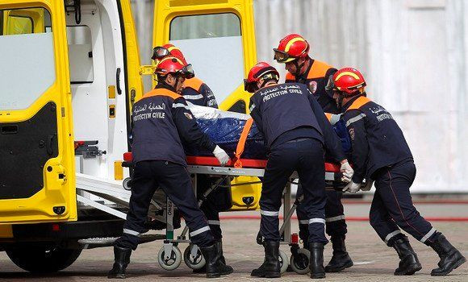
A teenager was killed on Monday by lightning in the wilaya of Guelma, the civil protection directorate said in a statement.
The incident occurred at the level of a village in the commune of Ain Larbi, in the daïra of Ain Makhlouf, said the same source, stressing that the firefighters intervened on the scene “at 18h16 to rescue and transport a struck-down person.
The victim is 14 years old whose lifeless body has been transferred to the morgue of the local hospital, the statement added.

