Burundi : a violent explosion disrupts President Ndayishimiye’s visit to a gold mining cooperative in Mugina – Burundi
https://www.sosmediasburundi.org/en/2025/11/16/burundi-a-violent-explosion-disrupts-president-ndayishimiyes-visit-to-a-gold-mining-cooperative-in-mugina/
16 November 2025
By SOS Médias Burundi
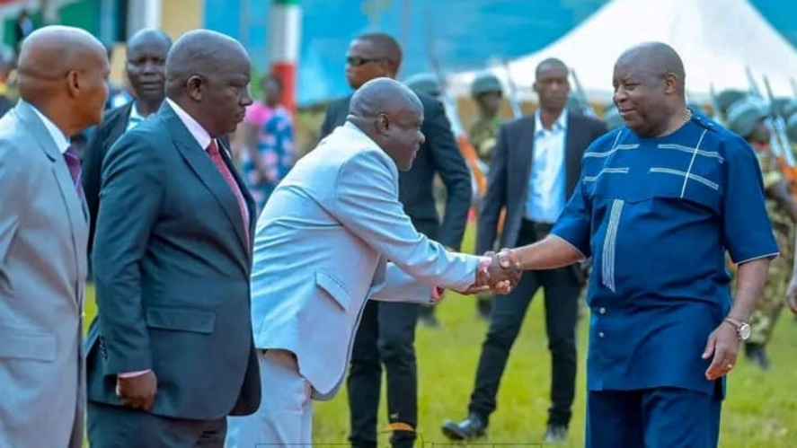
Mugina, November 15, 2025 — A powerful explosion, described by witnesses as a lightning strike, caused panic on Friday during a visit by Burundian President Évariste Ndayishimiye to a gold mining cooperative in Mabayi. Three members of his security detail were seriously injured.
The head of state had just officially installed the new head of the Mugina district, Anicet Saidi, in the Mabayi zone town center in Bujumbura province, western Burundi. He then visited the site of the Dukorere Ahabona mining cooperative, located in Mageyo village in the Butahana zone (same district), also in Bujumbura province. This gold mining cooperative is managed by a man named Musafi.
A detonation plunges the visit into chaos
As the president toured the site, a natural phenomenon described as a violent detonation followed by a powerful flash suddenly struck the surrounding area. According to several witnesses, the explosion threw everyone present, including the president, to the ground.
Three soldiers assigned to his close protection detail were seriously injured and rushed to a medical facility. The scene deeply shocked those present.
Despite the incident, Évariste Ndayishimiye assured the residents that mining represents “essential wealth for Burundi” and an important driver of economic development.
A cooperative under close surveillance
According to several local sources, the Dukorere Ahabona cooperative is partially linked to the interests of the Head of State, who reportedly shares its management with Musafi. The mining equipment, the vehicles transporting the ore, and some of the logistics equipment come from departments attached to the presidency, these same sources claim.
Access to the area is strictly controlled. Military personnel maintain constant surveillance, prohibit any unauthorized access, and severely limit visibility into daily activities.

