Niger: Seven dead and 29 injured since the start of the rainy season- Niger
https://airinfoagadez.com/2026/06/13/niger-sept-morts-et-29-blesses-depuis-le-debut-de-la-saison-des-pluies/
13 June 2026
By Ahmadou Atafa
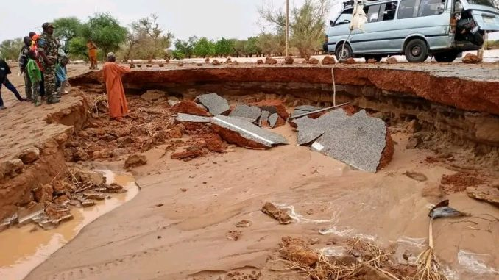
The weather related to the rainy season left seven dead and 29 injured in Niger, according to a report published Saturday, June 13 by the authorities.
In Niamey, heavy rains accompanied by strong winds caused the death of two children in the morning. Their parents were injured and taken care of at the reference hospital, according to the city’s Managing Director, Colonel Boubacar Soumana Garanké.
In several neighborhoods, the waters quickly invaded the streets. Houses, businesses and various facilities were also damaged.
National road No. 25, which connects Niamey to Balleyara, was heavily damaged at the village of Goguezé, located about forty kilometers from the capital.
Hundreds of households affected in several regions
At the national level, the Crisis Monitoring, Warning and Control Operational Centre (COVACC) indicates that 220 households, or about 1,500 people, have been affected since the beginning of the rainy season in the regions of Niamey, Dosso, Tahoua and Zinder.
A toll from the Directorate General of Civil Protection, relayed by the COVACC, reports seven deaths, 29 wounded as of June 13. Authorities also report the loss of 62 head of livestock, mainly as a result of collapses and lightning.
Civil protection services call for vigilance over the risk of floods and weather, which are frequent every year during the rainy season.
According to official figures, more than 920,000 people had been affected by the floods in 2025, up from nearly 1.5 million in 2024.

