Fate Of Family In Limbo, After Grandmother’s Tragic Death In Lightning Strike - Liberia
https://newspublictrust.com/fate-of-family-in-limbo-after-grandmothers-tragic-death-in-lightning-strike

12 May 2026

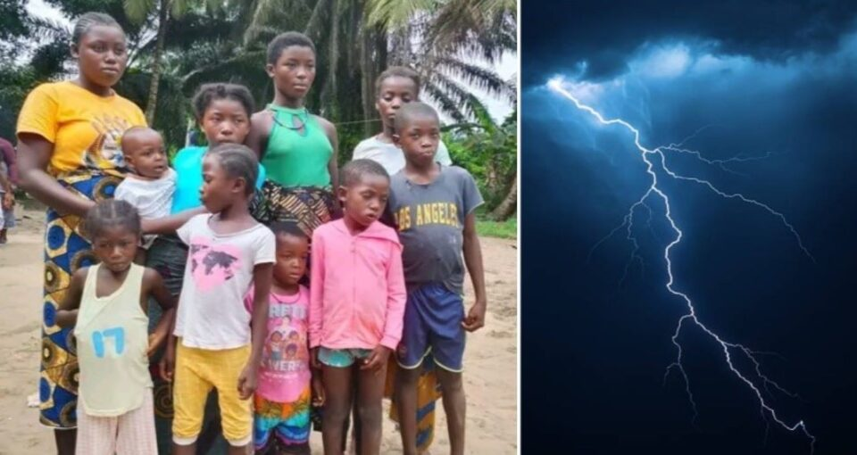

In Picnicness, Grand Kru County, Liberia
By Emmanuel Koffa
For many years, Juah Tarplah Barsseh was the pillar holding her family together in Picnicess, Grand Kru County.
After losing her husband years ago, the elderly mother and grandmother took on the difficult responsibility of raising seven children and caring for more than ten grandchildren through subsistence farming. Neighbors say despite her age and hardships, she remained committed to ensuring her family had food to eat and hope for the future.
But on Friday, May 8, 2026, tragedy struck unexpectedly.
During a heavy storm that swept across the area, Barsseh reportedly left her bedroom and attempted to move into the sitting room when lightning pierced through the house and struck her. According to relatives, the impact threw her to the ground as terrified family members screamed for help.
“She was everything for the family,” a grieving relative, E.D. Swen, said emotionally. “Since her husband died, she has been struggling alone to care for the children and grandchildren.”
Residents rushed the elderly woman to a nearby health facility, hoping she could survive. But medical workers later pronounced her dead.
The heartbreaking incident has left the family not only mourning but also deeply worried about survival. Several children who depended on her daily support are now uncertain about who will provide food, school materials, and care.
Community members describe the late Barsseh as a quiet and hardworking woman who spent most of her life farming to sustain her household despite difficult conditions in the rural community.
“She suffered a lot, but she never gave up on her children,” said resident Jerome Sikar. “Now the children are left without both parents.”
As grief hangs over the family, relatives are appealing to humanitarian organizations, government officials, and compassionate citizens to provide assistance for the children and grandchildren left behind.
For the family in Picnicess, the storm did not only take a life — it took away the person they depended on most.

