**Report on Public Education and Engagements**

**Rock View Primary School, Tororo, Uganda**

**Location:** Rock View School, Tororo Municipality  
**Program:** Education and Community Engagements  
**Dates:** 22nd & 23rd April 2025  
**Prepared By:** Godwin Atwiine, Education Coordinator  
**Edited By:** Akantambira Barnabas, Country Coordinator

**I. Introduction**

In a continuing effort to safeguard lives from the dangers of lightning strikes, our team visited Rock View School in Tororo District to assess and enhance lightning safety and education. ACLENet had installed a Lightning Protection System (LPS) at the school in 2019 and this program builds on that foundation by promoting awareness among pupils, teachers, and the wider community.

**II. Program Objectives**

The key objectives of the visit were:

* **Promote Lightning Safety Awareness:** Educate pupils and staff about lightning safety measures.
* **Community Sensitization:** Follow up on district/municipality leaders’ engagement plan to raise community awareness on lightning hazards.
* **Empower School Leadership:** Strengthen the capacity of school leaders and staff to manage and maintain lightning safety initiatives.

**III. Preparatory Engagement**

**Meeting with the Head Teacher**

On 21st April 2025, our team met with the head teacher, Mrs. Bernadette Olokojo, to review program arrangements. During this preparatory discussion at the school office, we exchanged views on:

* The effectiveness of the installed LPS.
* Current challenges related to safety and maintenance.
* Strategies for integrating lightning safety into the everyday activities of the school.

Mrs. Bernadette highlighted that Rock View School is heavily populated—with an enrolment of approximately 2113 pupils, 37 teaching staff, and 17 non-teaching staff—thus increasing the risk in case of lightning strikes. She expressed profound gratitude for ACLENet’s work and stressed the importance of ongoing collaboration, particularly through the lightning safety committee (now headed by teacher Kiliana) that will work closely with the ACLENet team.

Additionally, our discussion touched on safeguarding the LPS. Mrs. Bernadette explained that strict regulations have been issued to security personnel to protect school property; any damage or loss would result in immediate accountability. She also underscored the need for regular supervisory visits by ACLENet to ensure the system’s continued effectiveness.

Mr. Martin Omara, the Project Manager, reaffirmed ACLENet’s commitment to this initiative while emphasizing that sustaining the system ultimately rests with the school leadership.

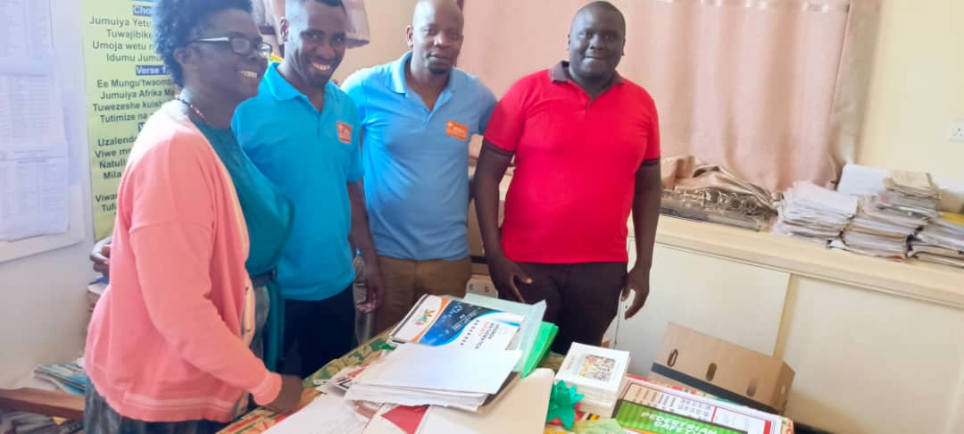

ABOVE: Mrs. Bernadette, the head teacher Rock View school, Mr. Godwin, education coordinator ACLENet, Mr. Isaac Tumuhimbise, Chief Installer ACLENet and Mr. Martin Omara, Project Manager ACLENet in the office of the Head teacher at Rock view school before the meeting.

**IV. Field Implementation**

**A. Student Education Sessions**

Owing to the large student body, educational sessions were divided into manageable groups:

1. **Day 1 – Session with Classes P6 to P7**
   * **Participants:** 486 pupils
   * **Focus:** Emphasis was placed on the importance of using the designated safe areas (classrooms) during lightning storms. Pupils were informed about the role they play in safeguarding the LPS and were encouraged to lead by example.
   * **Interactive Component:** Pupils were invited to ask questions, with common inquiries addressing issues such as why the LPS is not installed in toilets or near trees.

Below is Godwin, the Education Coordinator, and Mr. Barnabas, the Country Coordinator of ACLENet, engaging with P6 and P7 students in a combined session on lightning safety and protection.

1. **Day 2 – Session with Classes P4 to P5**
   * **Participants:** 844 pupils
   * **Focus:** Despite the higher numbers, the presence of teachers facilitated effective communication. Pupils received guidance on following safety protocols, particularly avoiding direct contact with electrical installations or wires.

Below is Godwin, the Education Coordinator, and Mr. Barnabas, the Country Coordinator of ACLENet, engaging with P4 and P5 students in a combined session on lightning safety and protection.

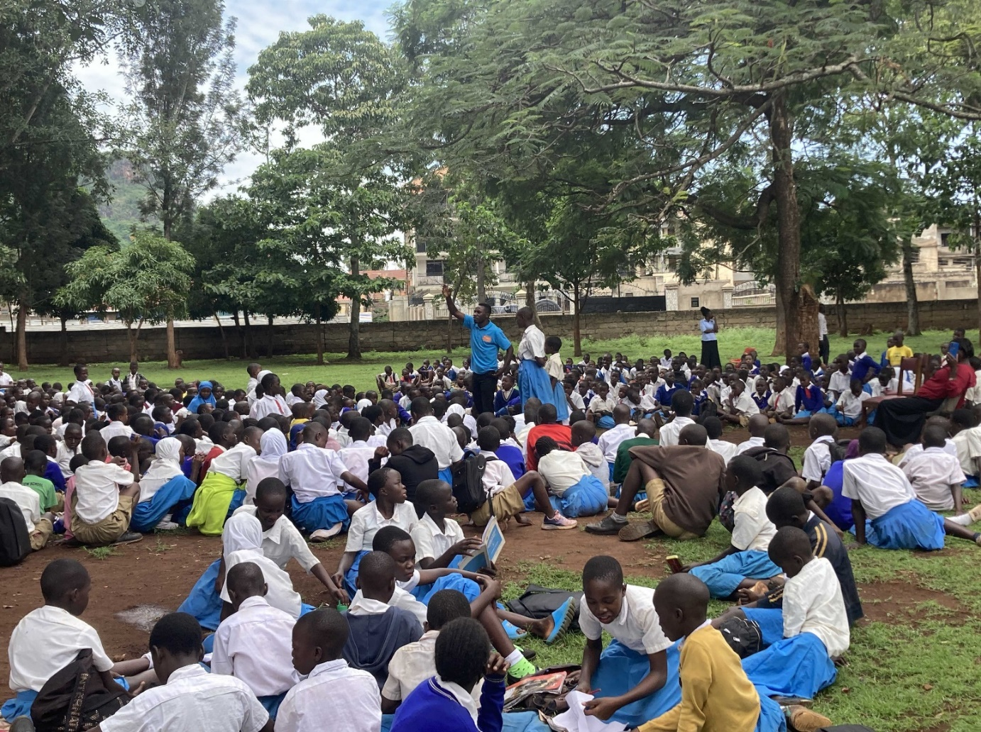

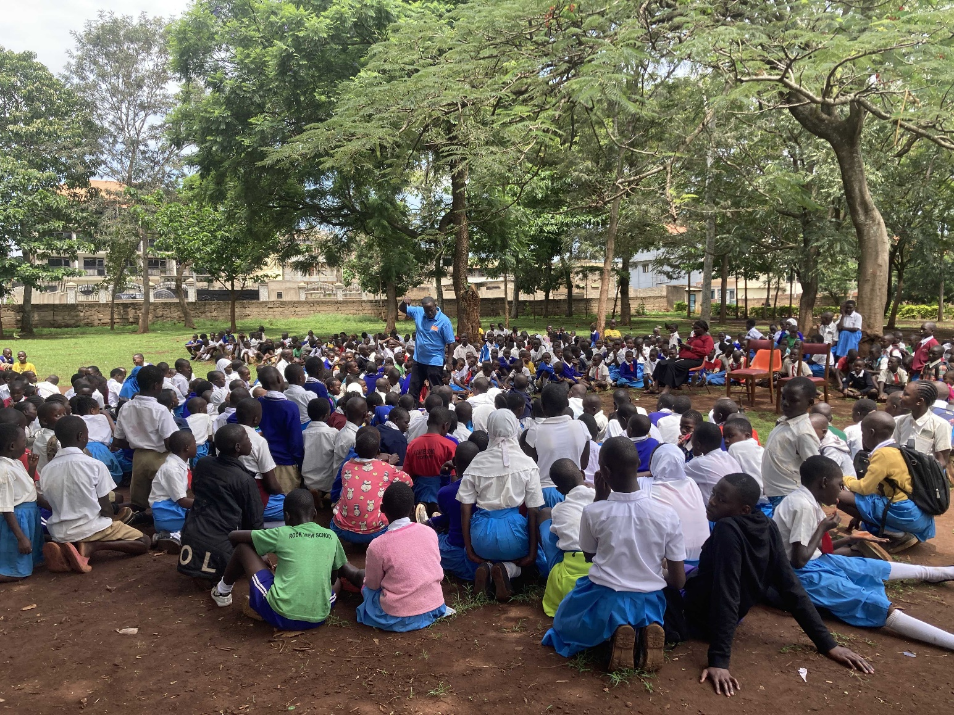

***Note:*** Due to examination schedules, classes P1 to P3 were not in session during these engagements.

**B. Teacher and Staff Engagement Meeting**

An interactive meeting was held with the teaching staff to discuss:

* Integrating lightning safety messages into daily classroom activities.
* Establishing and empowering a dedicated lightning safety club at all levels (nursery, lower primary, and upper primary).
* Using visible displays in classrooms and the school compound to reinforce safety guidelines.

In this meeting, Mr. Godwin Atwiine and Mr. Barnabas emphasized the role of teachers as front-line communicators of key messages on lightning protection. Participants proposed further training sessions to bolster the teachers’ technical knowledge of the LPS and stressed that public education on these matters should be ongoing—not a one-time event. The meeting concluded with a commitment to utilize Rock View School as a training hub in collaboration with the district disaster committee and Municipality leadership.

Above, Mr. Godwin Atwiine clearly outlines the critical need for lightning safety education in schools and the role of teachers as the primary conduit for conveying essential safety information to both learners and their parents.

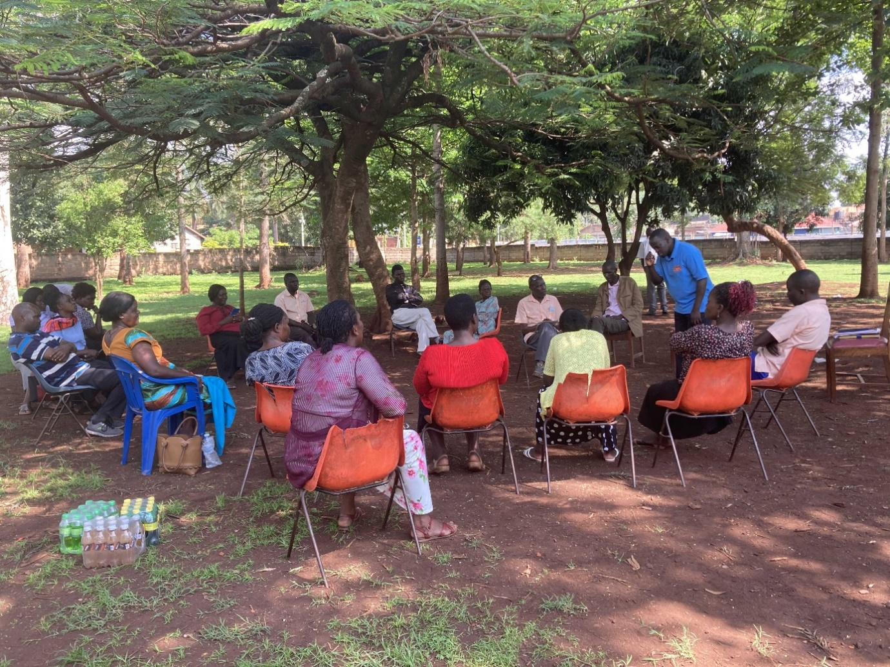

Above, Mr. Barnabas, the Country Coordinator, shared the fundamental principles of lightning safety with the teachers while emphasizing ACLENet’s commitment to maintaining a robust partnership in promoting community safety.

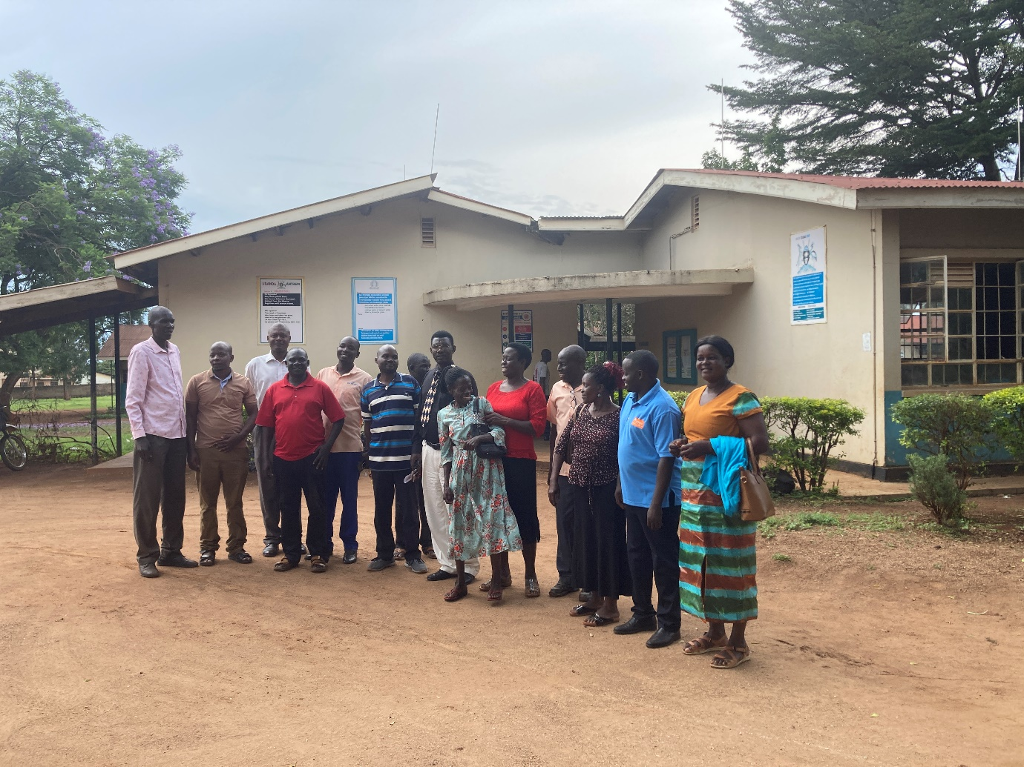

**Teachers after the meeting:**  
Following the engagement session, the teachers emerged energized and focused, actively discussing practical ways to integrate lightning safety guidelines into their classrooms. Their commitment not only reflects a deep understanding of the vital role they play in safeguarding the school community but also highlights their readiness to adapt and implement the new safety protocols as part of a comprehensive educational initiative.

**V. Key Outcomes and Recommendations**

**Outcomes:**

* Enhanced awareness and readiness among pupils and staff concerning lightning safety.
* Strengthened collaboration between the school’s lightning safety committee and ACLENet.
* Clear plans to integrate ongoing training and the establishment of lightning safety clubs.

**Recommendations:**

1. **Teacher Training:** Organize additional training workshops for teachers to master basic lightning safety messages and LPS operations.
2. **Safety Club Formation:** Assist the school in establishing and supporting lightning safety clubs through the provision of guidelines and safety materials.
3. **Improved Display Materials:** Support the school in acquiring and developing effective display materials for both indoor and outdoor settings.
4. **Capacity Building:** Leverage Rock View School as a model training centre for public education and community sensitization in partnership with the district disaster committee.
5. **Committee Strengthening:** Fully empower the school lightning safety committee by replacing departed members and filling vacant positions.

**VI. Conclusion**

The two-day engagement at Rock View School was a productive step towards furthering lightning safety in a high-risk setting. While the head teacher’s unexpected illness led to temporary delegation of responsibilities, the deputy head teacher and the school staff maintained excellent coordination, ensuring the success of our program. Continued collaboration, frequent supervisory visits by ACLENet, and a commitment to regular training will be essential to safeguard the lives and property of the school community.

**VII. Next Steps**

* **Follow-up Visits:** ACLENet will continue periodic supervisory visits to assess the maintenance of the LPS and the integration of safety practices into daily school life.
* **Extended Training:** Workshops for both teachers and community leaders will be organized to broaden the impact of our public education and sensitization programs.
* **Monitoring & Evaluation:** A formal review will be scheduled to evaluate the effectiveness of interventions and to refine strategies for ongoing lightning safety enhancements.

**Prepared By:**

GODWIN ATWIINE

Education Coordinator.

**Edited By:**

Akantambira Barnabas