**Lightning Kills 11 in Masindi in Three Weeks – Uganda**

<https://www.newvision.co.ug/category/news/lightning-kills-11-in-masindi-in-three-weeks-NV_216816>

20 August 2025

By Yosam Gucwaki  
  
Residents of Masindi district are living in fear following a series of tragic lightning strikes that have claimed 11 lives in just three weeks.

Speaking to *New Vision Online*,  Albertine north Police region commander Damalie Nachuha said three separate incidents have been reported between July and August 2025, resulting in multiple fatalities and injuries.

On August 17, 2025, David Gahweera, a resident of Nyakarongo village in Kimengo sub-county, was killed by lightning while in the garden with his wife.

On August 8, 2025, at about 7:45pm, lightning struck Bombo-Kibibira Market in Kiruli sub-county, allegedly killing five people and injuring several others.

The incident occurred during a heavy downpour as residents sought refuge under a huge tree in Kibibira Market.

According to eyewitnesses, seven individuals were struck by lightning, with an 11-year-old boy dying instantly.

Three others succumbed to their injuries while being rushed to Masindi Hospital, and one more person died upon arrival at the hospital.

Tende Mathius Oswa, the district councillor representing Pakanyi sub-county, confirmed that two of the bodies had been transported to Kigumba sub-county where they had come from to sell their goods in Kibibira market.

Robert Okumu, the aspiring LC3 chairperson, described the incident as the most shocking he'd ever witnessed, adding that the area was gripped with fear.

"We had never witnessed this in the area," Okumu said, highlighting the community's distress.

On July 13, 2025, four young people weeding a sugarcane plantation in Kyarutanga village, Kijunjubwa sub-county, were killed, while eight others were injured. The deceased were identified as Olegirwth (20), Bright Tekakwo (22), Jodan (19) and Brian (18).

**Safety measures**

Following the increasing lightning incidents, Nachuha is urging the public to take necessary precautions during rainstorms.

She advises residents to stay indoors, avoid using electronic devices, and wear shoes to reduce the risk of being struck by lightning.

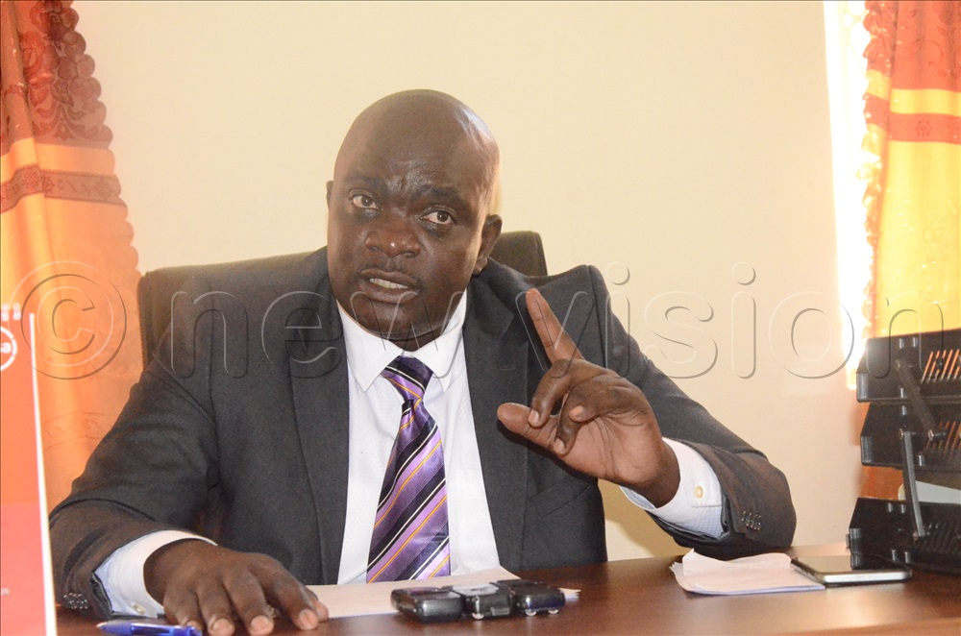

***The Masindi Municipal Council mayor, Ronald Businge Kyomuhendo, has also begun engaging building owners to install lightning arresters in public structures to protect lives.***

The Masindi Municipal Council mayor, Ronald Businge Kyomuhendo, has also begun engaging building owners to install lightning arresters in public structures to protect lives.

**Public reaction**

The recent incidents have left residents demanding urgent action to prevent further losses. Many are calling for the installation of lightning arresters in public buildings, including markets, schools, health centres and entertainment venues, which currently lack such safety measures.

**Other strikes around the country**

Lightning strikes are uncommon in much of Uganda, but there are areas where they have struck and turned fatal for the victims.

Last year alone, lightning strikes claimed over 10 lives. On November 2, 2024, a lightning strike hit a Catholic chapel in Palabek Refugee Settlement's Zone 2, Block 8, killing 14 people, while 34 others were left with multiple injuries.

Lightning strikes claimed over five lives in 2023 around the country.

For instance, on September 6, 2023, it was a double tragedy in Yumbe district after lightning struck two children dead.

On March 16, 2023, two members of the same family in Rukungiri district died on the spot after they were struck by lightning.

Kigezi region Police spokesman Elly Maate identified the victims as Enoth Tukwasibwe, 30 and his mother, Jolly Baryakabuza, 75, both residents of Keita Village in Nyabitete Parish, Bugangari sub-county.

On March 12, 2023, residents of Rwamuyoora village in Rubanda district, western Uganda, were gripped with fear and shock after lightning killed three people: A father and his two sons.

The incident happened during an afternoon downpour at Rwamuyora cell, Nyarurambi parish, Muko sub-county.

According to a statement released by Kigezi region Police spokesperson Elly Maate, the incident occurred at about 2:00pm as Ambrose Kanunu, 35, was in the main house with his two sons identified as Justus Asiimwe, 7 and Arnold Habomugisha, 5.

In August 2020, lightning killed 10 boys at a football pitch in Gbulukua cell, Ayivu division in Arua city.

The boys aged between 13 and 15 were playing football when heavy rain forced them to take refuge in a nearby grass-thatched house, which was later struck by lightning.

In October 2018, three children died after being struck by lightning at Mongoyo Primary School in Yumbe district's Drajini sub-county.

In the same year, a lightning strike at Kebir Cell, Kenya Ward in Arua city's central division, left a 16-year-old boy dead. The deceased, Sabir, had reportedly gone to visit his three friends when the thunderbolt struck him dead.