Tragedy in Basra: a young woman killed by lightning – Tunisia
https://cridem.org/C_Info.php?article=787029
11 September 2025
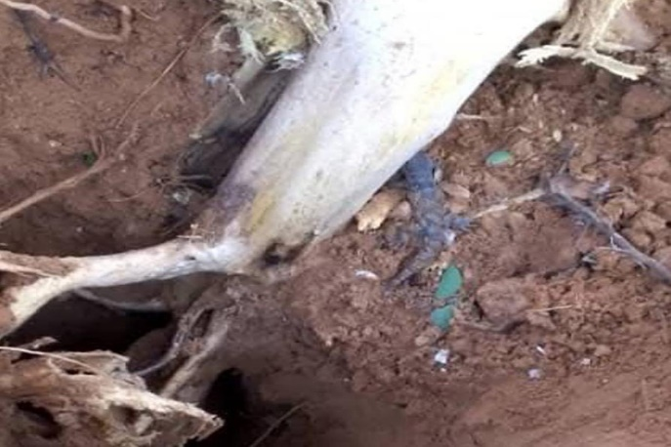
SHEMS MAARIF - A tragedy occurred this Thursday in the village of Basra, located in the wilaya of the Hodh El Gharbi, where a powerful lightning has cost the life of a young woman, Houeiriya Mint Khliva.
According to several witnesses, lightning struck in the heart of the village, causing panic among the inhabitants. The phenomenon, sudden and violent, surprised everyone.
“We heard a deafening noise, and then saw a blinding light. Moments later, we learned that Houeiriya had been affected,” said Mohamed, a resident of the village.
“It was a shocking scene. People were screaming, some were running in every way. We had never seen such a powerful lightning here,” adds Fatimetou, the victim’s neighbor.
This tragedy highlights the lack of vigilance in the face of weather risks. Despite the safety instructions often recalled in the event of a storm, many people continue to expose themselves unnecessarily, sometimes with tragic consequences.
Images obtained by our editorial staff show the damage caused by the impact of lightning in the area. An investigation could be opened to determine the exact circumstances of the tragedy.

Respect your interlocutors: To ensure quality debates, a key word: the respect of the participants. Give everyone the right to disagree with you. Press your answers on facts and arguments, not on invectives.
Unlawful content: The content of comments must not violate applicable laws and regulations. In particular, racist or anti-Semitic, defamatory or insulting remarks are unlawful, disclosing information relating to the privacy of a person, using works protected by copyright (texts, photos, videos, etc.).
Cridem reserves the right not to validate any comments that may contravene the law, as well as any off-topic, promotional or rude commentary. Thank you for your participation in Cridem!
Comments and comments are the property of their author(s) and are only binding on their opinion, opinion and responsibility.

