Incident in a food market in Kinshasa kills dozens of people - DRC

https://www.africanews.com/amp/2022/02/03/incident-in-a-food-market-in-kinshasa-kills-dozens-of-people/
By Africanews Last updated: 13/08/2024

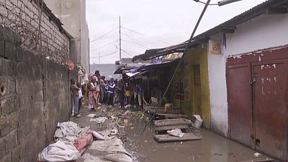
Newscast video available on website
At least 26 people died electrocuted in DRC's capital, Kinshasa, after a high voltage power cable snapped and fell into a drainage ditch.
The incident occurred in a popular food market and most victims were market traders and customers.
This witness describes what she saw.
"When the rain started, a thunderstorm suddenly hit the electricity cable pole (high voltage), when the cable gave way, in its fall, the cable started to hit the people around and as there was water on the ground, many people started to collapse successively", said Gracias Lelo.
The national power company, SNEL, attributed the incident to a lightning strike that severed the cable.
"This high voltage cable which caused the death of several mothers, ....... So that's why we came to identify the families so that we could bring help", said Bienvenu Akilimali, Advisor to the Minister for Gender, Family and Children.
An official from the state-owned company added that the land ministry had ilegally issued permits for market stalls placed under the cables.
Many traders also blame the poorly-maintained drainage system.
Witness Gracias Kabemba denounced the electricity company.
"The SNEL (national electricity company) should monitor their equipment, they earn a lot of money by monitoring their equipment, it will be good for the safety of their customers".
Last month, Congolese president, President Felix Tshisekedi, had announced the rapid relocation of the market due to the dangers posed by its location.

