Disasters kill 67 in five months as lightning emerges deadliest hazard – Rwanda
https://www.newtimes.co.rw/article/32674/news/environment/disasters-kill-67-in-five-months-as-lightning-emerges-deadliest-hazard
18 January, 2026
By Charles Nyandwi

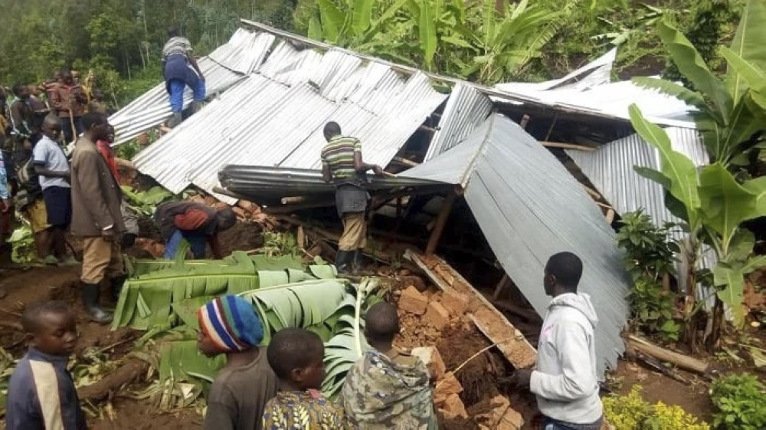
More than 470 disaster incidents have been recorded across Rwanda since the onset of the rainy season in September, leaving at least 67 people dead and 123 others injured.

More than 470 disaster incidents have been recorded across Rwanda since the onset of the rainy season in September, leaving at least 67 people dead and 123 others injured, according to the Ministry in Charge of Emergency Management (MINEMA).
The data obtained by The New Times covering the period between September 1 and January 15 show that disasters also destroyed 674 houses and damaged food crops on more than 406 hectares of land.
In addition, 33 head of cattle were lost, while key infrastructure was affected, including nine bridges, two water supply systems and 29 electricity transmission lines.
Lightning strikes
Lightning emerged as the deadliest hazard, accounting for 45 deaths, representing 61 per cent of all disaster-related fatalities. It was also responsible for nearly all livestock losses, causing 96.9 per cent of cattle deaths. Floods followed, claiming the lives of 13 people.
House collapses were the second leading cause of injuries, with 22 people over the five-month period.
Hailstorms caused the most extensive crop damage, destroying about 300 hectares, equivalent to 75 per cent of all affected farmland. Floods damaged 43.3 hectares, while mining-related disasters affected 33.6 hectares.
Ngoma District recorded the highest number of incidents, with 44 cases that killed 12 people and injured 22 others. Gicumbi followed with 37 incidents, although with fewer casualties, recording two deaths and 10 injuries.
Gakenke registered 32 incidents, resulting in six deaths and 11 injuries, while Kayonza reported 21 incidents that left seven people dead.
As authorities seek to curb the impact of disasters, officials say a range of preventive and response measures are being prioritised this year, particularly to address lightning-related incidents.
Christine Hitimana Niyotwambaza, Director General for Surveillance and Preparedness at the emergency ministry, said progress is being made towards locally manufacturing lightning rods, in partnership with academic institutions and the private sector.
“In collaboration with Rwanda Polytechnic College of Karongi and with support from International Organization for Migration (IOM), we are still discussing how to locally manufacture lightning rods. As part of the discussion, we are planning a workshop to develop a clear roadmap with actionable steps to improve the prototype already produced by the college,” she said.
She added that the workshop will be facilitated by Electricom, a local company that previously supported RP-Karongi College in developing the prototype and provides electrical training under an existing memorandum of understanding.
Electricom is expected to propose a training plan, including associated costs, after which further meetings involving MINEMA, RP-Karongi College, Electricom and IOM will be held to agree on the next steps, she added.
Adalbert Rukebanuka, Director General for Policy, Planning and Risk Reduction at MINEMA, said the ministry’s focus this year is on strengthening disaster risk reduction while improving preparedness and response mechanisms.
“We are prioritising risk identification, analysis and assessment for different types of hazards, so that prevention and response measures are based on evidence,” Rukebanuka said.
He noted that public awareness remains critical in reducing disaster impacts, particularly as climate-related risks intensify.
“We are increasing nationwide awareness on disaster risks through mass and digital media to ensure communities understand the dangers and how to respond,” he said.
Rukebanuka added that MINEMA is also strengthening coordination and response systems to ensure affected populations receive timely support.
“Our focus includes assessing the needs of disaster-affected people during and after emergencies, coordinating the distribution of relief assistance, and providing psychosocial support to the most vulnerable,” he said.
He further said the ministry is equipping strategic stores with relief items and strengthening rescue and evacuation systems, while operationalising district emergency command posts to improve local response capacity and safeguard lives.

