North Kivu: significant human and material damage after a violent rain in Beni – DRC
https://journaldesnations.net/nord-kivu-dimportants-degats-humains-et-materiels-apres-une-pluie-violente-a-beni/
30 January 2026
BY Glory TSONGO
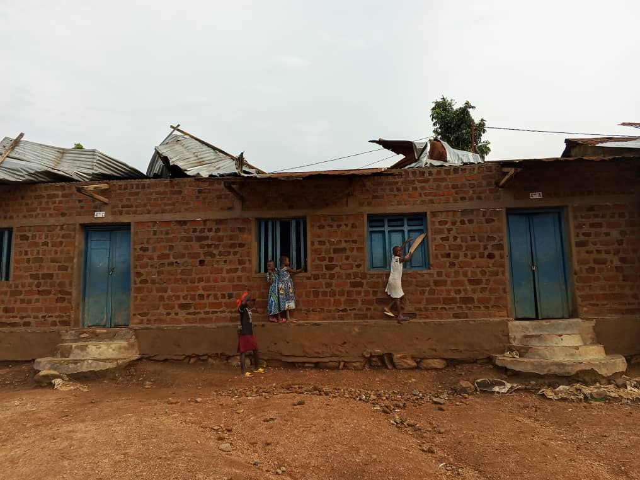
A torrential rain accompanied by strong winds fell on the city of Beni, in the province of North Kivu, this Friday, January 30, 2026 around 15 hours, causing significant human and material damage in several neighborhoods.
In the commune of Beu, precisely in the Butanuka district, a young girl tragically lost her life after being struck by lightning. This is 18-year-old Kavugho Sadiki Dieula. The tragedy occurred shortly after the rain, while strong gusts of wind and violent lightning were observed in the area.
According to the civil society of the municipality of Beu, the body of the victim was transported in a health structure of the place for the procedures of use.
Very moved, the rapporteur of this citizen structure, Chiffer Kabonga Kimbulungu, delivered a first provisional assessment: "We are deeply saddened by the death of this young girl from the Butanuka district. She was struck by lightning after the rain. In addition to this death, several houses have been demolished in the neighborhood. We mourn our sister.”
In addition to this loss of life, several homes were damaged and schools were torn off, exposing students and families to the weather.
In the face of this situation, civil society is calling on the competent authorities and humanitarian organisations to intervene urgently to help the affected families. It also urges the population to be cautious during this period marked by rains often accompanied by strong winds and thunderstorms.

