Mahina: Lightning decimates a herd of goats in Tangafoya – Mali
https://www.studiotamani.org/193469-mahina-la-foudre-decime-un-troupeau-de-chevres-a-tangafoya
28 August 2025
By Msindebou
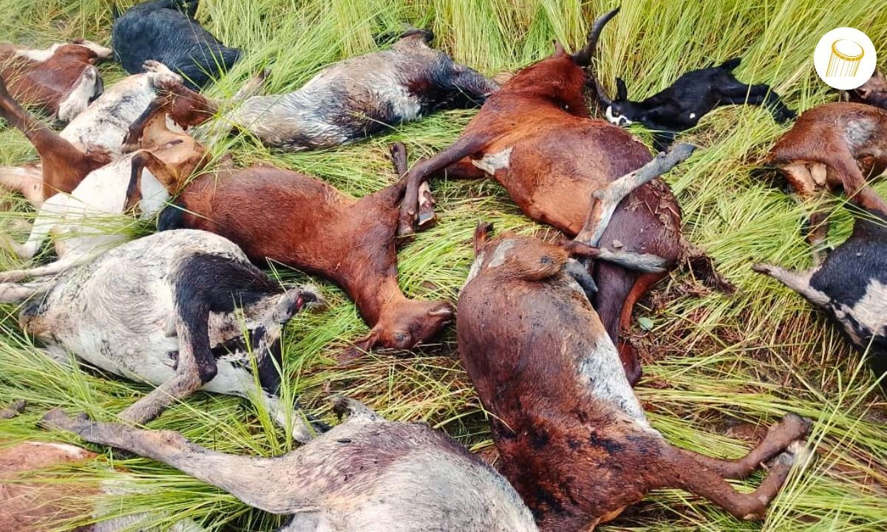
A herd of goats fell in Mahina by lightning, August 27, 2025
On the night of Tuesday 26 to Wednesday 27 August 2025, a violent storm shook the village of Tangafoya, in the commune of Mahina, a circle of Bafoulabé.
The lightning fell on a herd of goats, killing 25 animals. Four could be rescued by the inhabitants who gave them fresh milk, according to the owner. No loss in human life has been recorded. Last year, a woman lost her life after being struck by the same village.

