**REPORT ON THE INSTALLATION OF A LIGHTNING PROTECTION SYSTEM AT PALABEK SECONDARY SCHOOL, LAMWO-UGANDA**

Date: 24 February 2025

**Project Details**

* **Project Name:** Lightning Protection System Installation for Four Blocks and Repairs of Existing LPS at Palabek Secondary School
* **Location:** Lamwo District
* **Dates:** 16th – 22nd February 2025
* **Installer:** Isaac Tumuhimbise, Chief LPS Installer
* **Project Manager:** Omara Martin

**Introduction**

This report provides a detailed account of the installation of a lightning protection system (LPS) at Palabek Secondary School, located in Lamwo District. The installation was conducted by Isaac Tumuhimbise, Chief Installer, and Omara Martin, Project Manager from ACLENet, over the course of a week, from February 16th to 22nd, 2025. The primary objective of this project was to safeguard the school buildings and enhance the safety of both students and staff during thunderstorms.

Lightning poses a significant threat to educational institutions, often resulting in severe damage to infrastructure and posing risks to life. Recognizing the urgent need for robust lightning protection, ACLENet undertook this project to install an effective LPS that would provide comprehensive protection and peace of mind to the school community.

**Objectives**:

The key objectives of the project were:

* **Protection from Lightning Strikes:** To safeguard the newly constructed four blocks and existing buildings, ensuring the safety of students and staff during thunderstorms.
* **Compliance with Standards:** To meet the specifications of IEC 62305.

**Scope of Work** The scope of work for this project encompassed the installation of lightning protection measures on four newly constructed blocks. Specifically, the protected blocks included:

* **Blocks:** F, G, H, and I

Each of these blocks was fitted with the necessary components to form a comprehensive lightning protection system. The installation process involved careful planning and execution to ensure all structures within the school premises were adequately protected.

**Fig 1: Sketch of Palabek secondary school**

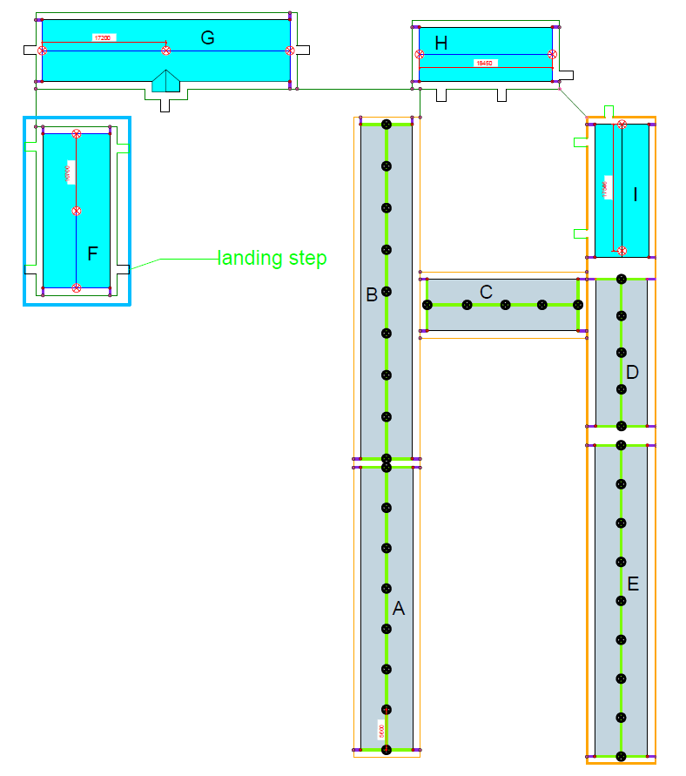

**Planning and Preparation**

* **Initial Site Survey:** Conducted a thorough survey and assessment of existing roofing and ground conditions to determine the optimal installation strategy.
* **Design of Repairs and for new buildings:** Lightning Protection Working Group
* **Review of Drawings:** Reviewed the LPC drawings and ensured all regulatory standards and safety protocols were met.

**Installation Process**

The installation process involved several key steps:

* **Air Terminals:** Installed according to LPC/ACLENet LPWG drawings.
  + **Roof Conductor Holders:** Fixed to the roof, which presented challenges due to the steep angles.
  + **Earth Termination Network:** Round wire 10mm St/tZn coil length 81m.
  + **Trenching:** Dug 0.7m deep trenches for grounding conductors, overcoming obstacles such as hard, dry ground.
  + **Testing Joints:** Ensured all connections were secure and complied with regulatory standards for maximum safety and efficiency.

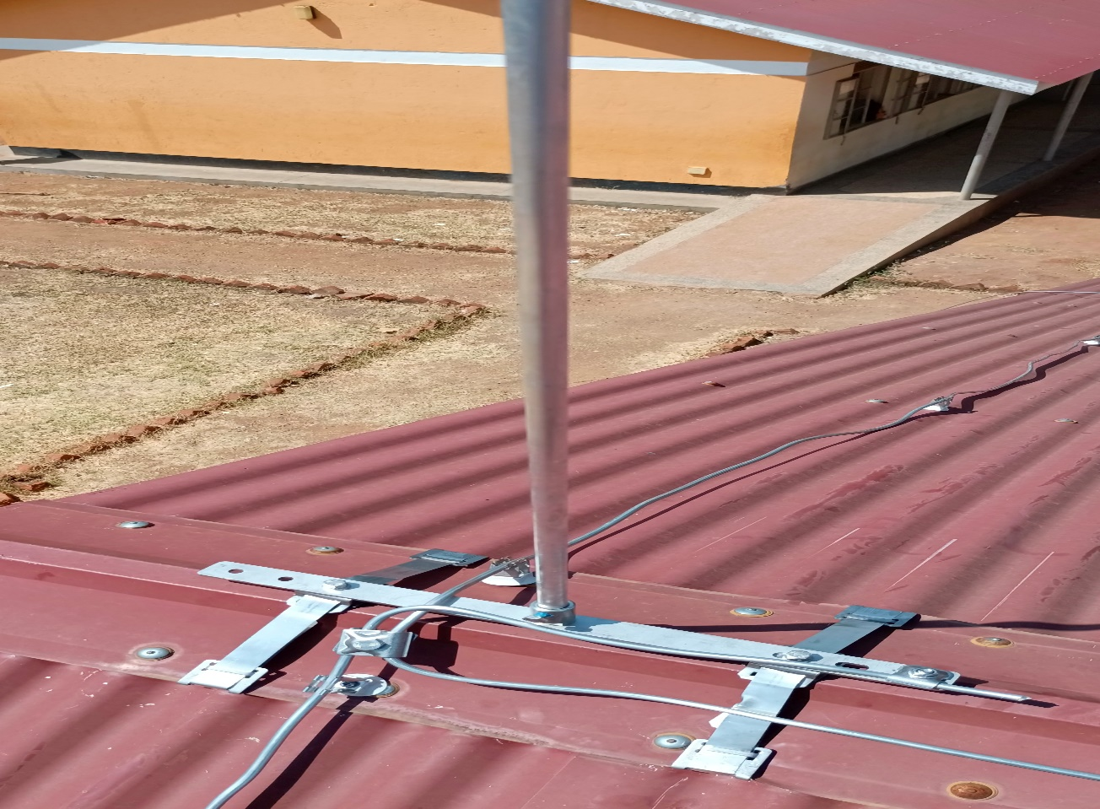

*Fig2 shows the air terminal on block H*

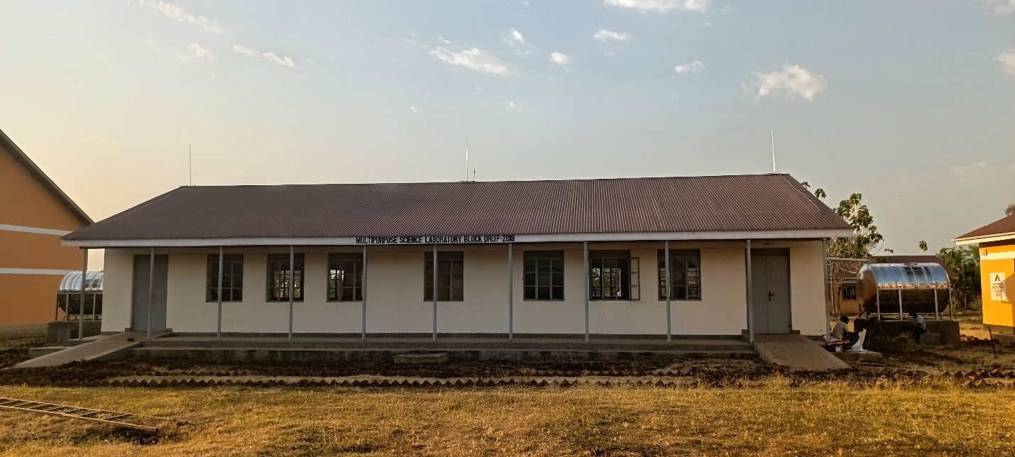

*Fig 3: shows the south direction of block F*

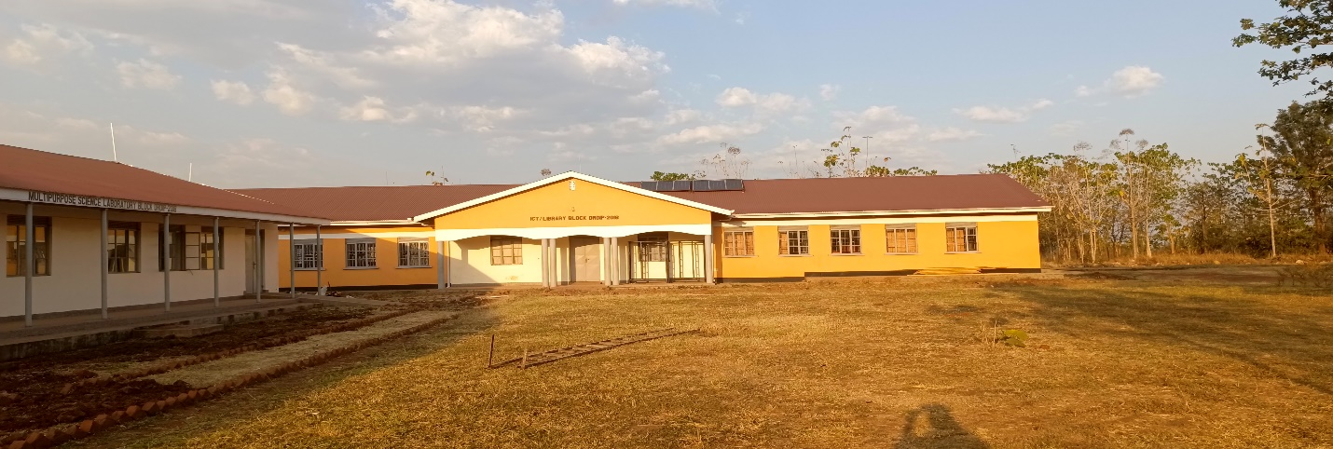

*Fig 4: shows the south of block H and west direction of block G*

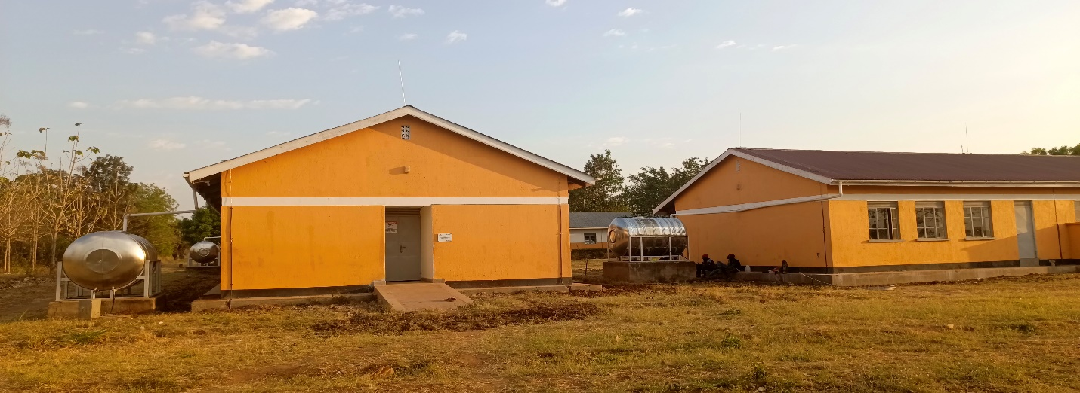

*Fig 5: Shows the north direction of block G and F*

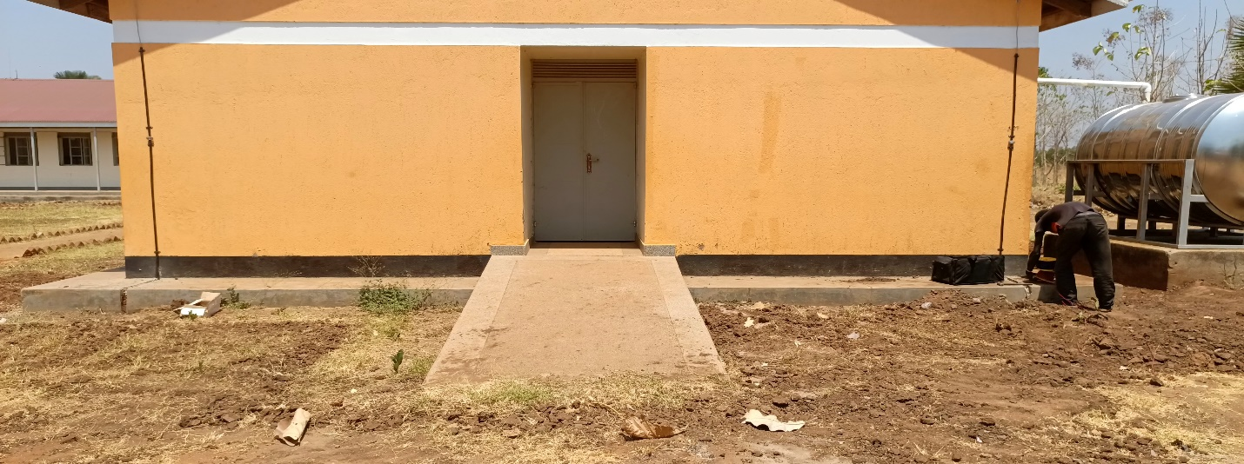

*Fig 6: shows the landing steps that were not included in the estimation of earth ring conductor*

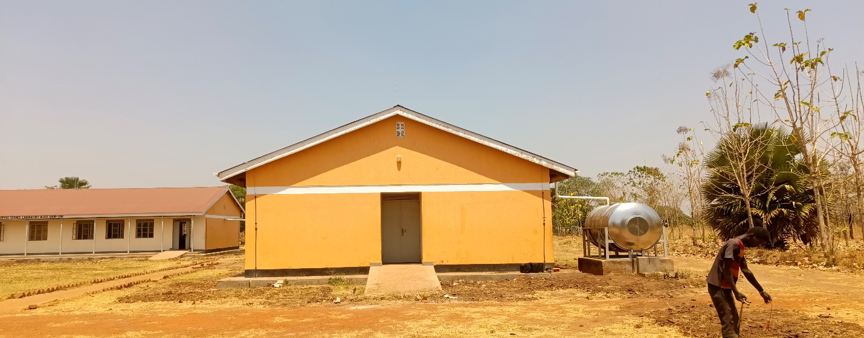

*Fig 7 Shows the south direction of block F and G (From left to right)*

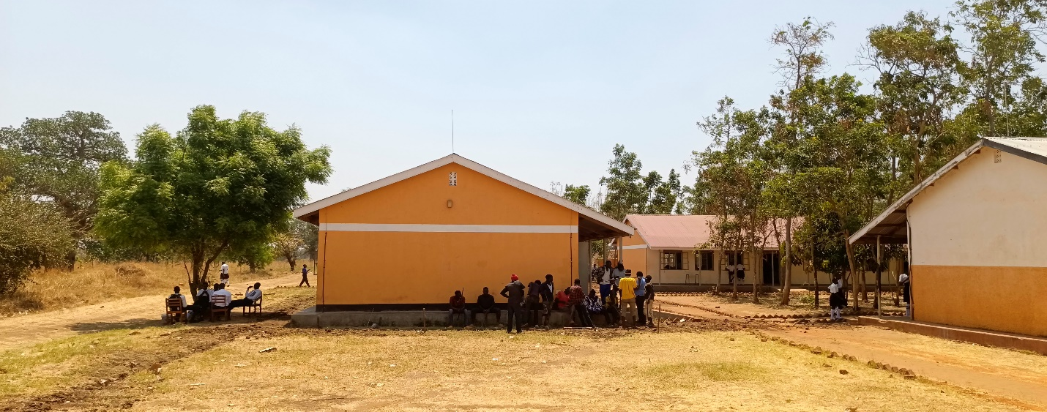

*Fig 8: Shows the north direction of Block H and the casual laborer after completing the whole work.*

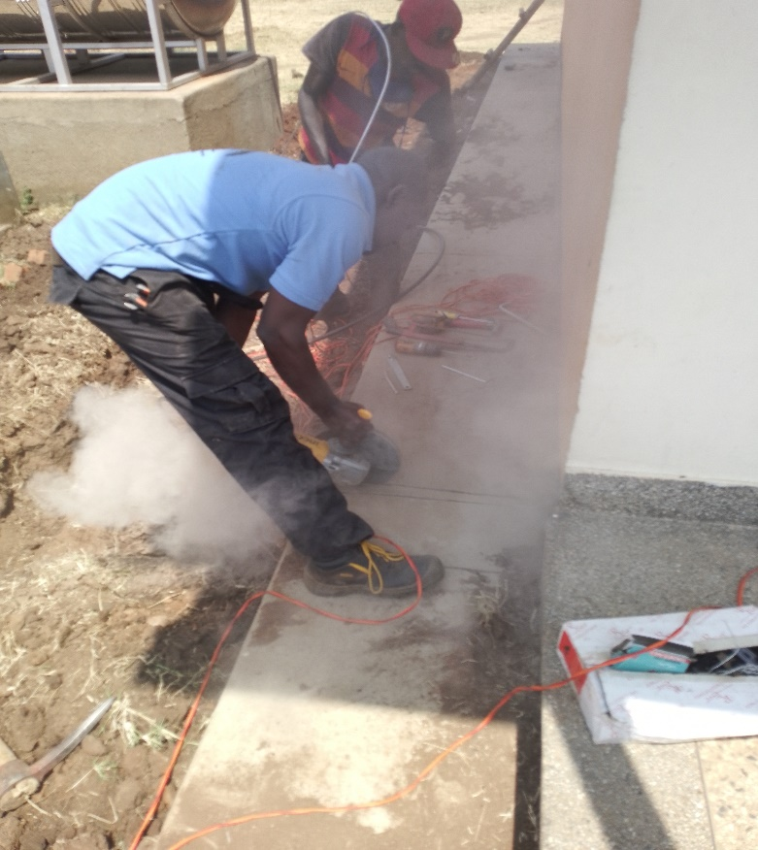

*Fig 9: Isaac chief installer demonstrating to a casual laborer how to cut a veranda*

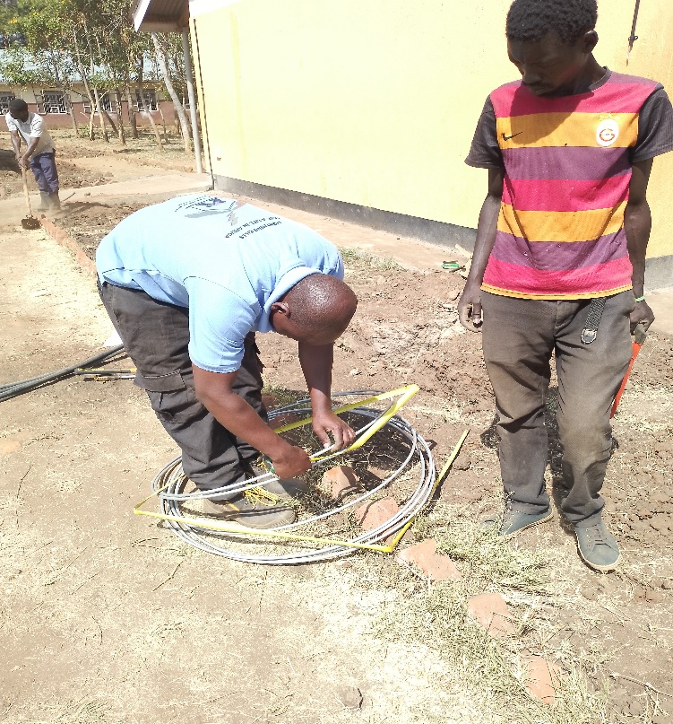

*Fig 10: Isaac cutting earth ring*

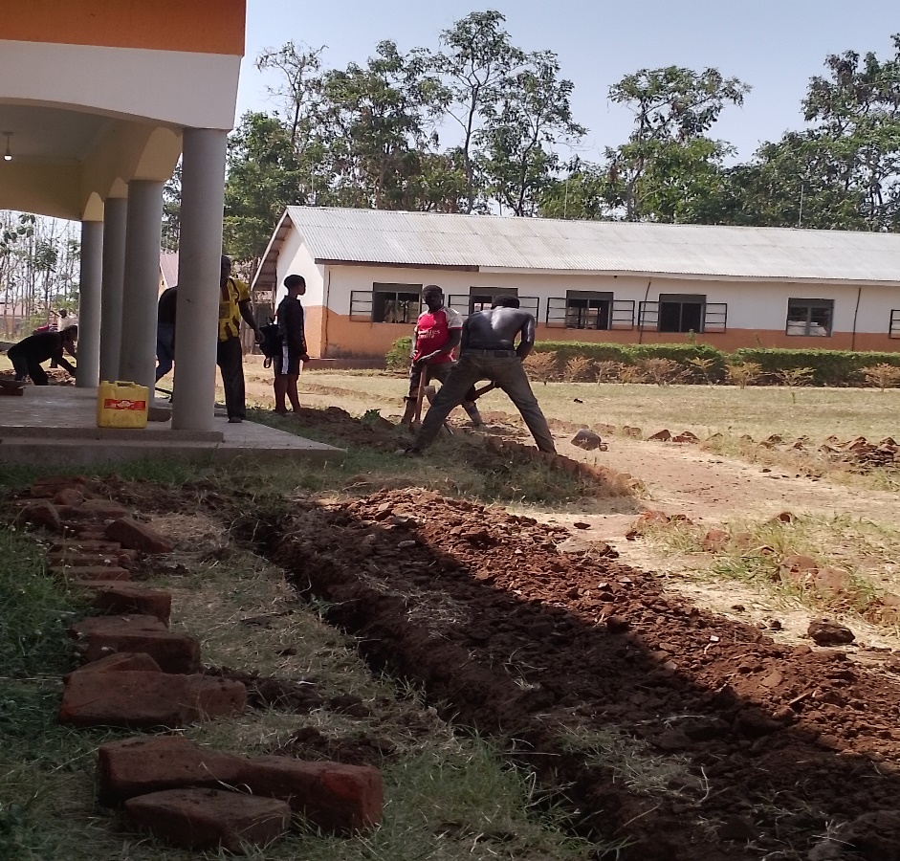

*Fig 11: casual laborers digging trenches*

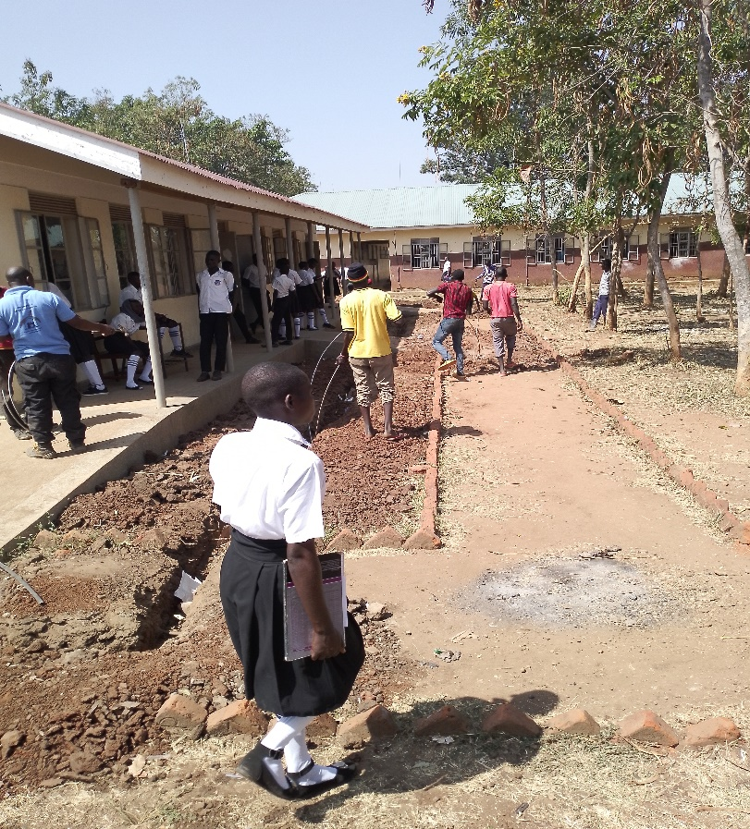

*Fig 12: casual laborers fixing earth rings*

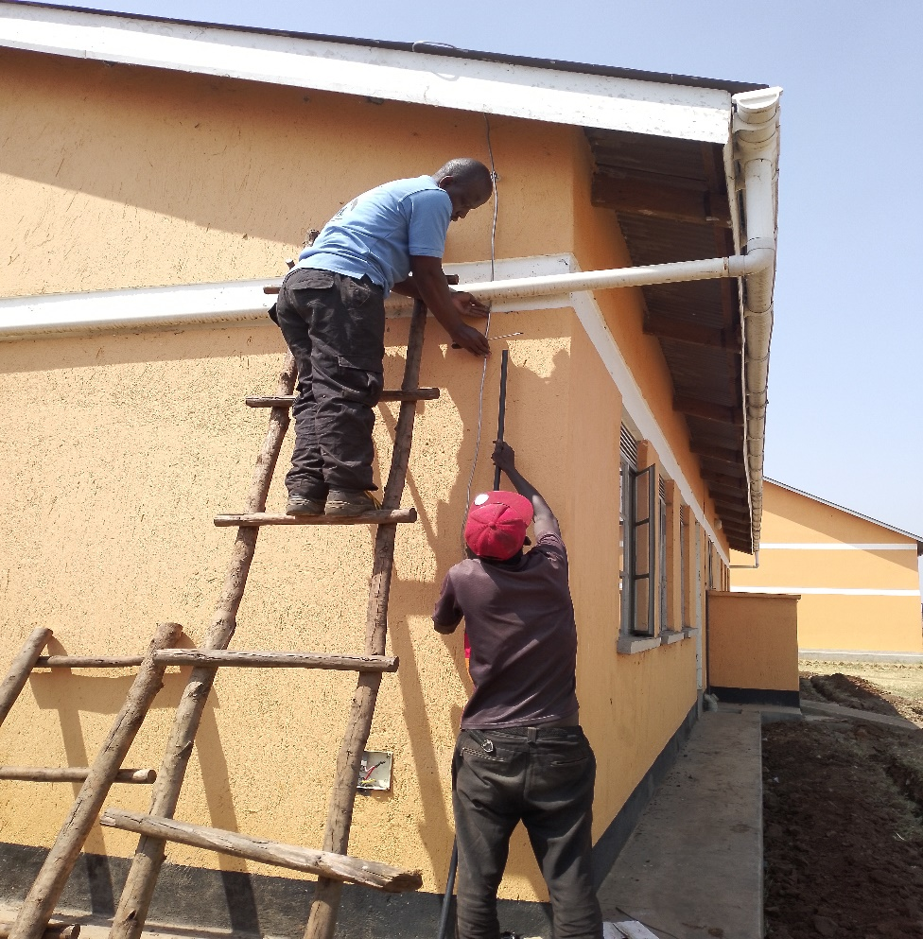

*Fig 13: Isaac fixing down conductors*

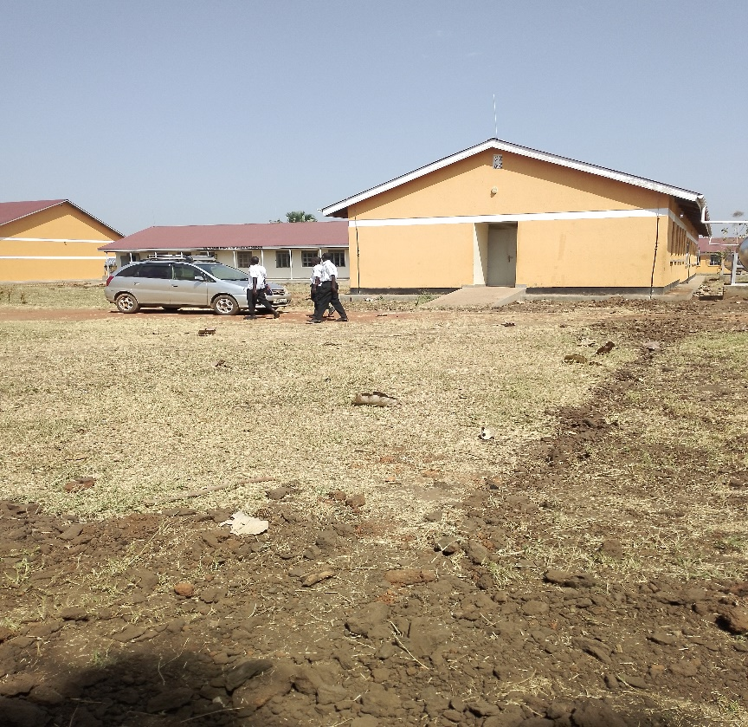

*Fig 14: earth ring connecting block G and block H*

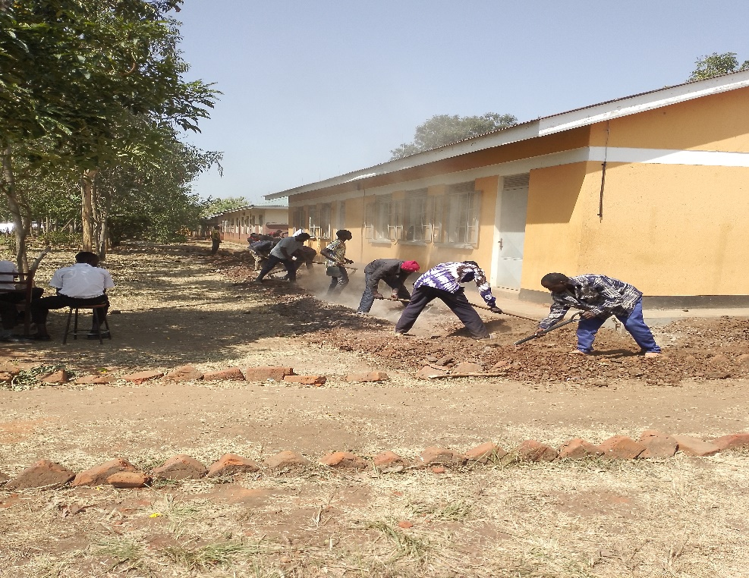

*Fig 15: Casual laborers back filling trenches*

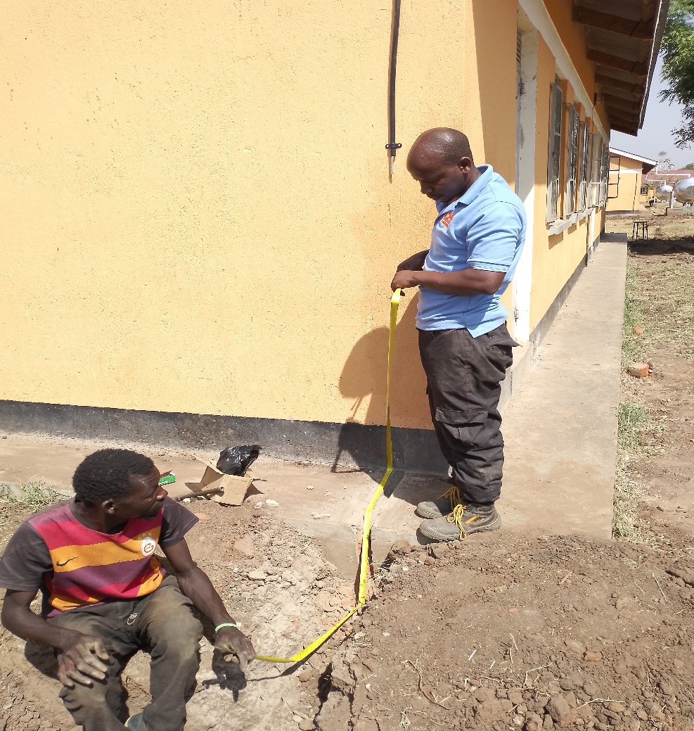

*Fig 16: Isaac fixing down conductor*

**Challenges Encountered**

The team faced several challenges during the installation:

* **Limited Casual Labor:** Hiring laborers at a higher cost due to poor communication (school management delaying getting sufficient labor for trench digging in time).
* **Poor weather/Too much heat:** there was a lot of heat which was up to 42˚ Celsius, thus making the roof very hot for the installer to climb.
* **Hard ground:** the ground was very hard for the casual laborers to dig through thus increasing the price and time taken for digging the trenches making the project more expensive.
* **Straightening Conductors:** Difficulty in straightening galvanized conductors.
* **Dust and Poor roads.** The road to Palabek is too rough thus damaging Martin’s Vehicle which was used during installation process since Barnabas was busy engaging with district officials
* **Challenge of accommodation:** the team had to drive over 80km daily to look for better accommodation in a nearby town (Kitgum municipality)
* **Incorrect Component Estimates:** Some LPS components were incorrectly estimated, including the MV clamp StSt f. Rd 8-10mm with hexagon screw and the KS connector StSt f. Rd 6-10mm single-part unit with spring washer, round wire 10mm St/tZn coil length 81m.
* **Community Training Requests:** The local community frequently requested training materials on LPS design and factors to consider.

**Results**

The installation of the lightning protection system at Palabek Secondary School was successfully completed. The system now ensures a safe learning environment for both students and staff, effectively mitigating the risks posed by lightning strikes.

**Recommendations**

1. **Engage Local Community Volunteers:** Select suitable Volunteers from the local school community to assist the chief lightning protection system installer with tasks such as clipping lightning conductors on the roofing. This fosters community involvement and ensures the availability of assistance.
2. **Provide Insurance for Installers:** Given the inherent risks involved in climbing on roofs and handling installation tasks, insurance coverage should be allocated for installers to ensure adequate compensation in the event of an accident.
3. **Early Communication with Schools:** Ensure early communication with headteachers to arrange for capable casual laborers in a timely manner.

**Installation Details** **Materials Used:**

|  |  |  |  |  |  |
| --- | --- | --- | --- | --- | --- |
| **Item No.** | **Part No.** | **Description** | **Qty planned** | **Qty used** | **Remark** |
| 1. | 103,410 | Tubular air-term. rod D 16mm L 1500mm AlMgSi F22 tapered to 10mm | 10PC | 10 pcs | Enough |
| 2. | 123,110 | Holder f. air-terminal. systems D 10mm at ridge a. hip tiles w. tens. strap StSt | 10PC | 10 pcs | Enough |
| 3. | 390,059 | MV clamp StSt f. Rd 8-10mm with hexagon screw | 20PC | 40 pcs | Not Enough |
| 4. | 840,018 | Round wire DEHNalu 8mm AlMgSi coil length 148m soft-torsion able m | 160M | 157 M | Enough |
| 5. | 207,109 | DEHN grip conductor holder StSt f. Rd 8mm H 20mm with dowel 8x40mm and  wood screw | 160PC | 140 pcs | Enough |
| 6. | 301,019 | KS connector StSt f. Rd 6-10mm single-part unit with spring washer | 48PC | 16 pcs | Extra enough |
| 7. | 301,019 | UNI disconnecting clamp, StSt with intermediate plate for 2x Rd 8-10mm | 14PC | 14 pcs | Enough |
| 8 | 800,010 | Round wire 10mm St/tZn coil length 81m | 273M | 405M | The walkway/steps to the classrooms were not considered in the calculation |
| 9. |  | 3/4” pvc conduit | 14 | Pcs | Enough |

**Tools Used:**

* Wrenches
* Pliers (pumping pliers)
* Screwdrivers
* Hammers
* Tape measures
* Levels
* Hacksaw
* Cordless drill
* Electrical drill
* Ladders
* Grinder
* Hoes
* Pickaxes
* Spade

**Certification**

I, **Isaac Tumuhimbise**, Chief LPS Installer, certify that the lightning protection system (LPS) for the four blocks at Palabek Secondary School was installed in full compliance with LPC’s design and specifications.

**Conclusion**

The installation of the lightning protection system (LPS) at Palabek Secondary School in Lamwo District has significantly enhanced safety during thunderstorms. Conducted by ACLENet from February 16th to 22nd, 2025, this project successfully provided lightning protection for four additional blocks at the school.

**Compiled By:**

1. **Chief Installer:** Isaac Tumuhimbise
2. **Project manager:** Omara Martin

**Edited By:**

1. Akantambira Barnabas.