Enoch Mgijima Municipality Visits Families of Traditional Nurses Killed by Lightning – South Africa
https://www.komani.co.za/enoch-mgijima-municipality-visits-families-of-traditional-nurses-killed-by-lightning/
13 December 2025
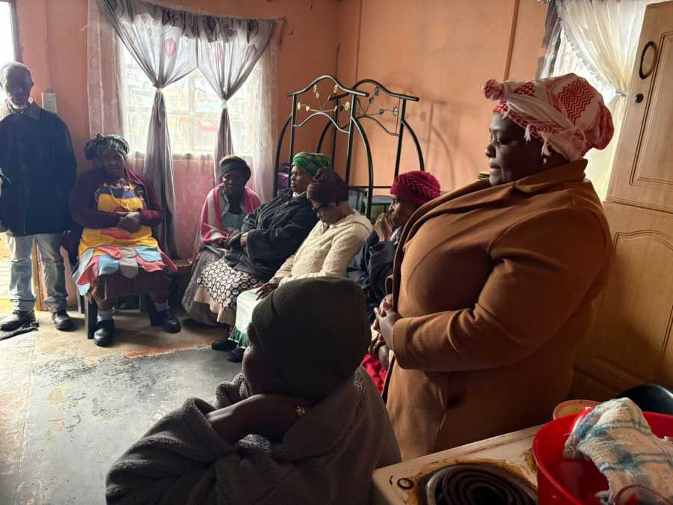
By Komani News
Molteno, Eastern Cape
The Enoch Mgijima Local Municipality has paid tribute to three traditional nurses who tragically lost their lives after being struck by lightning at an initiation school near Molteno.
Family games
A municipal delegation led by Councillor Unathi Galada, the Portfolio Head for Budget and Treasury, together with Ward 28 Councillor Nombulelo Makasi, visited the homes of the deceased this week to express condolences and offer support to the grieving families.
The three men were serving as traditional nurses at the time of the incident and were responsible for caring for and protecting young initiates undergoing the traditional initiation process. Their deaths have sent shockwaves through the Molteno community and the broader Enoch Mgijima area.
Municipality Pays Respects
According to the municipality, the purpose of the visit was to express sympathy, provide emotional support, and honour the contribution and sacrifice of the three men. The delegation acknowledged the critical role that traditional nurses play in safeguarding initiates and preserving cultural practices.
Thunderstorm preparedness kit
Family members received the delegation at their homes, where discussions focused on support, solidarity, and remembrance during a time of deep mourning.
Community in Mourning
The incident has raised renewed concern around safety at initiation schools, particularly during severe weather conditions that are common in parts of the Eastern Cape during summer. Lightning strikes have previously claimed lives across the province, including at initiation sites and rural homesteads.
While this incident was caused by natural forces, it has highlighted the vulnerability faced by traditional practitioners who often work in open or rural environments with limited shelter.
Eastern Cape tourism
Traditional Initiation Under Scrutiny
The Eastern Cape has experienced multiple tragedies linked to initiation seasons over the years, prompting ongoing calls for improved oversight, safety planning, and emergency preparedness at initiation schools. Government departments, traditional leaders, and municipalities continue to work together to reduce risks and prevent further loss of life.
The municipality reiterated its commitment to working with traditional leadership structures to promote safer initiation practices while respecting cultural traditions.
Honouring Their Sacrifice
The three traditional nurses have been described by community members as dedicated individuals who placed the well-being of initiates above their own safety. Their deaths have left families, initiates, and the wider community mourning a significant loss.
Lightning protection systems
The municipality concluded the visit by paying homage to the men, recognising their service and bravery, and offering continued support to the affected families.

