South Kanem: 33 camels killed by lightning in Djami Boulalah – Chad
https://manara.td/sud-kanem-33-dromadaires-tues-par-la-foudre-a-djami-boulalah/
13 September 2025
By Djidda Mahamat Oumar,
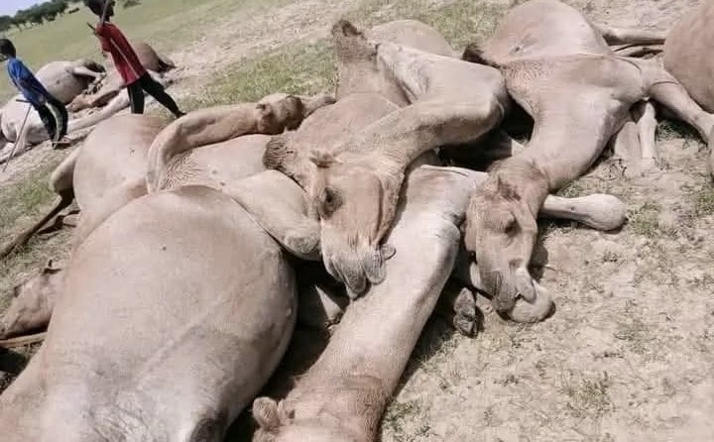
On the night of Saturday, September 13, around 1 a.m., an incident occurred in the village of Djami Boulalah, located in the canton of Mourzougui, sub-prefecture of Mondo, department of South Kanem, Kanem province.
According to a local source, lightning struck a herd of camels belonging to a family of Arab nomadic breeders led by Mahamat Zene Al Hissein. The toll is heavy: more than 33 camels have died instantly. This loss is a blow to the family, whose livelihoods are mainly based on livestock farming.
Faced with this dramatic situation, the president of the Association pour le Développement de Mondo (ADM), Mr. Ali Younouss Ali, has made an urgent appeal to NGOs, government authorities and people of good will to provide urgent assistance to this hard-won family.

