AMBATOMIRAHAVAVY - Lightning takes a life on the way – Madagascar
https://www.lexpress.mg/2026/02/ambatomirahavavy-la-foudre-enleve-une.html
6 February 2026
By Gustave Mparany
In Ambatomirahavavy, lightning struck, and with it extinguished the strength of a father who bore alone the weight of his family.
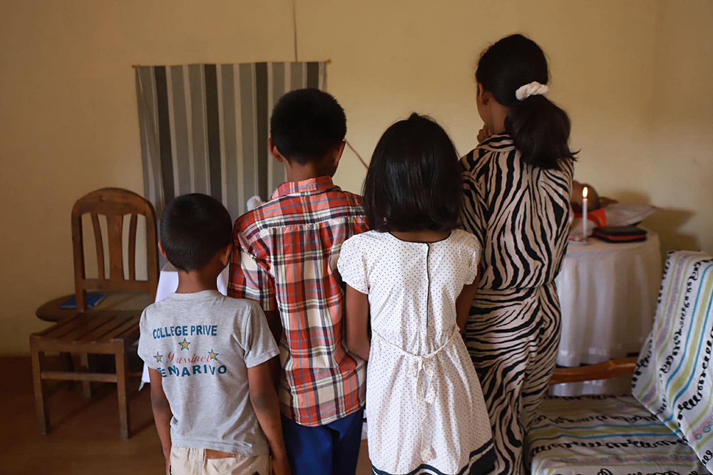
The four young children of the deceased gather before the lifeless body.
A lightning flash has broken the life of a family living in Arivonimamo. Wednesday, in the late afternoon, on the RN1 in Ambatomirahavavy, Lalatiana, 43, a father of four, was struck by lightning while returning home on his motorcycle with his youngest son.
The rain was falling, the thunder was rumbling and, suddenly, the sky opened to tear it away from life. Projected to the ground, he was rushed to CSB II in Ambatomirahavavy, where he succumbed to his injuries. His 7-year-old son miraculously escaped unscathed.
The fate of this man seemed already marked by pain. In October 2024, he lost his wife, Laingo, in a car accident in Tsarasaotra. Together they went to preach the gospel, accompanied by a sister in faith. The vehicle belonged to the latter, who was driving. During the accident, his wife was ejected and then fatally crushed by the car. She died instantly. Lalatiana had survived, injured but alive, forced to carry the weight of the family alone and become the only pillar of his children.
Since that day, he had assumed both the role of father and mother, raising his four children — two boys and two girls — aged 12, 11, 9 and 7. A discreet, unchatted man, he had more enclosed himself after the loss of his wife, according to his relatives.
Before you die
But behind this silence was an immense force, that of a father who, despite the trials, continued to fight for his children. In the last few days, two of them had been sick. The 12-year-old girl, who was prone to seizures, had to undergo tests, while the youngest boy had spent a day in hospital. It was to recover the medical results in Antananarivo that Lalatiana took the road on Wednesday, with her son on the scooter.
Lightning caused him severe burns to his hands and arms. When the family started preparing her body, they wanted to buy white gloves and socks. But the little boy revealed that his father had already bought it, having slipped them into his bag that same day, as if he were expecting him to leave. A few days earlier, he had also cut his hair, a gesture interpreted today as a final preparation, a silent way to get in order before the big trip.
His body was taken to Ananetikely, Fenoarivo, where the family owns a house. His four children, now orphans, will be taken care of by his sister, settled in Arivonimamo, so that their schooling is not interrupted. But no support can fill the void left by this father who, to the end, will have given everything for them.
And it is these white gloves and socks, bought by himself before they die, that cover his burnt hands today. Like a last gesture of love, a final fatherly caress, silent but upsetting.

