Kwango : 3 people struck by lightning in Misele - DRC
https://7sur7.cd/2026/02/19/kwango-3-personnes-foudroyees-misele
19 February 2026
By Chançard Sindani, in Kenge
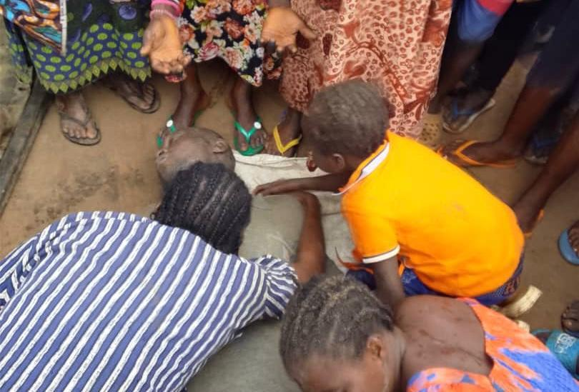
Heavy rain accompanied by thunderstorms fell on Wednesday, February 18, 2026, on several localities in the province of Kwango, causing a tragedy in the territory of Kenge.
Three people were killed by lightning in the village of Misele, located in the grouping of Misele, sector of Pelende-Nord.
According to information collected by 7SUR7. CD, the toll shows three deaths and ten wounded, currently being taken care of in local health facilities.
Lightning struck, taking three lives and leaving the community in shock. Among the victims are Jocelyne Kayala, Son Yamfu (son of Chief Kalenge and Transport Service Officer), and Mwana Mpini Françoise (Vender at the local market).
This tragedy plunged the entire community of Misele into dismay and aroused a strong emotion among the local population.

