Mali: More than 24 dead and 20 000 victims after the weather – Mali
https://sahel-intelligence.com/40285-mali-plus-de-24-morts-et-20-000-sinistres-apres-les-intemperies.html
6 October 2025
By Samuel Benshimon
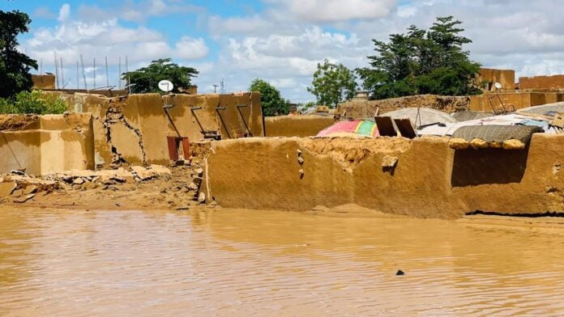
Mali is facing a particularly deadly rainy season. According to a report released on Friday by the Inter-Ministerial Committee for Crisis and Disaster Management, more than 20 500 people have been affected by flooding across the country since the beginning of wintering.
In all, 44 cases of flooding, 10 lightning strikes and 4 episodes of high winds were recorded as of October 2, 2025. These climatic hazards caused the deaths of 24 people, injured 35 others and resulted in the collapse of 1,237 homes, affecting 2 680 households.
“The government is fully mobilized to help the affected populations,” said Colonel Firefighter Issa Raoul Dana Dabo, director of the Center for Coordination and Crisis Management. He mentioned ongoing actions, such as the release of easements and beds from the swamps in Bamako, and the deployment of citizen brigadiers as part of the “Citizen Months” initiative.
The continued rise of water in the Malian rivers, particularly in Niger, Senegal and the Bani, is of concern to the authorities. According to Colonel Dabo, intense rainfall in the high basins fuels an upward trend, punctuated by dangerous variations in water level.
In addition, water releases are underway in the manantali and Selingue dams, which could lead to rapid rises in water level downstream. Populations living near rivers are therefore called to the utmost caution and invited to evacuate areas at risk or obstructing the flow routes.
The director of the Crisis Management Center also warned of the risk of lightning floods in Bamako, where the swamps react strongly to heavy rains. He urged residents to liberate flood-prone areas to limit the damage.

