Man struck by lightning – South Africa
https://www.pressreader.com/eswatini/eswatini-observer-9ZB3/20251104/281530822272607?srsltid=AfmBOoqSFI_HqpyJfEpj5Q4VESL1we39oUR7OFrrnDQe2RKTBTtf6ZR5
While an old man who had been ploughing fields with a tractor was found naked on the river banks of Ngwavuma River
4 November 2025
By Musa Nsibande
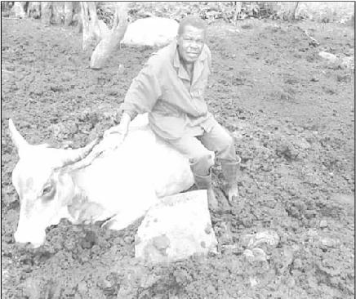


The late Zablon Gwebu.
TWO people were reported dead in the aftermath of the storm that wreaked havoc in several areas on
Saturday afternoon.
In one of the reported tragic incidents, two friends were caught in a thunderstorm in the mountain terrain of Tholulwazi, which is located close to the notorious Mehlwabovu Mountain, outside Hlatikulu.
In one of the reported tragic incidents, two friends were caught in a thunderstorm in the mountain terrain of Tholulwazi, which is located close to the notorious Mehlwabovu Mountain, outside Hlatikulu.
Relatives reported that the acquaintances were returning home when one of them was struck by lightning and died on the spot.
Relatives reported that the acquaintances were returning home when one of them was struck by lightning and died on the spot.
The deceased was identified as Sibusiso Shongwe (32) of Tholulwazi.
Severe weather descended over the area on Saturday afternoon while the friends were on their way home and they got caught in the thunderstorm.
One of the two lads was lucky to escape unscathed, while his friend was struck by a bolt of lightning.
The survivor managed to reach home where he raised the alarm.
The survivor managed to reach home where he raised the alarm.
His family members called the family of the victim.
Family members rushed to the scene and eventually located the deceased’s unresponsive body lying next to a pathway.
“These were young men who were returning home, either from watching soccer or doing other things young men do. Soccer was the deceased’s passion. We received a call informing us that he had been struck by lightning,” narrated a close family member of the deceased, who preferred anonymity.
“These were young men who were returning home, either from watching soccer or doing other things young men do. Soccer was the deceased’s passion. We received a call informing us that he had been struck by lightning,” narrated a close family member of the deceased, who preferred anonymity.
Police confirmed that lightning strike around the area and killed one person.
On the same day in the afternoon, in a separate and unrelated incident, tragedy struck another family when a 64-year-old man died after leaving home.
Family members said the deceased, who was identified as Zablon Gwebu, was driving a tractor with the intention to cultivate a few fields.
This was shortly before bad weather descended over the area of Sigengeni, outside Hlatikulu.
The tractor was later found abandoned next to the fields he was ploughing, with its keys in the ignition.
His unresponsive and naked body was found a few metres away, on the Ngwavuma River banks. The river cuts through Sigengeni.
One of his boots was recovered strewn a few metres away. The body had no visible wounds according to relatives.
One of his boots was recovered strewn a few metres away. The body had no visible wounds according to relatives.
Initial investigations suggest that the man may have stopped ploughing the field after he was disturbed by a swarm of bees.
But some have blamed the bad weather that descended over the area that day.
“Initially we thought he may have abandoned the tractor while fleeing from the bees. But there were no visible injuries supporting that assertion,” said Sanele Gwebu, the deceased’s son.
The police advised the family to wait a post-mortem.
Acting Chief Police Information and Communications Officer, Assistant Superintendent Nosipho Mnguni, confirmed both incidents.
A storm that hit parts of the country on Saturday afternoon brought devastation, especially to farming communities.
Power and water supply were cut off at Nisela Farm and surrounding areas as the storm pummeled the eastern and southern parts of the kingdom.
At neighbouring Lubulini, a few homes reported blown off roofs and extensive damage to crops.
Areas that were impacted by the storm included Big-Bend, Lubulini, Lavumisa and Hosea.

