**Known cyclone death toll reaches 14 - Mozambique**  
<https://aimnews.org/2025/03/16/known-cyclone-death-toll-reaches-14/>

16 March 2025

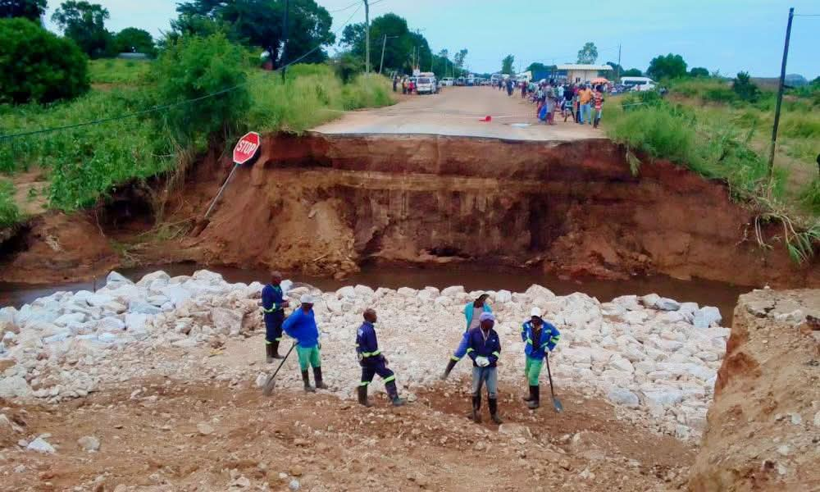

By [Paul Fauvet](https://aimnews.org/author/fauvet/)    
  
Maputo, 15 Mar (AIM) – The known death toll from cyclone Jude, which struck much of northern and central Mozambique on Monday and Tuesday, now stands at 14, according to the government spokesperson, the Minister of State Administration, Inocencio Impissa.

Speaking to reporters in Maputo on Friday, after a meeting of the Council of Ministers (Cabinet), Impissa said the number of people known to have been injured during the passage of Jude across Mozambique is 60.

The main causes of the deaths, he added, were the collapse of houses built of flimsy materials, lightning strikes, and drowning. The death toll is likely to rise as information reaches the authorities from outlying areas where roads and bridges have been washed away.

Impissa said the cyclone had destroyed 7,041 houses and damaged a further 13,139.

30 health units were damaged, and 182 classrooms in 59 schools, affecting 17,401 pupils and 264 teachers.

All the main access roads into Nampula province had been damaged, but by Friday afternoon traffic, at least of light vehicles, was flowing again between Nampula city and the rest of northern Mozambique.

The main north-south highway (EN1) had been cut at the Anchilo administrative post, about 15 kilometres from the city, and there was a yawning 20 metre gap in the road. Contractors hired by the National Roads Administration (ANE) built a diversion that bypassed the damaged stretch of EN1. Light vehicles could use this bypass, but not heavy trucks.

The Minister of Transport and Logistics, Joao Matlombe, visited Nampula to see the damage for himself. He said 800 million meticais (about 12.5 million dollars, at the current exchange rate), would be needed to repair the damage on six key stretches identified by the ANE.

Matlombe feared that a detailed survey would show the need for more complex, and hence more expensive, work, particularly on Nampula bridges.

The priority, the Minister said, is to find alternative routes so that traffic can flow, even in places where bridges have been destroyed. In places where vehicles cannot pass, the authorities are using boats, “since we have to supply households who need assistance, while the bridges have not yet been repaired”, he stressed”.

The cyclone also knocked down 19 electricity pylons, and swamped 1,262 hectares of cultivated land.

“Assessment of the impacts is continuing with multi-sector teams stationed in the affected districts”, said Impissa.

Nine accommodation centres were set up in Nampula for people driven from their homes by the cyclone and, as of Saturday, 1,985 people had taken shelter there.

The cyclone did not head west, into Malawi, as initially expected. Instead, it changed course, and swept across Zambezia province before re-entering the Mozambique Channel.

On Saturday morning Jude made landfall in southern Madagascar. Its forecast path will then take the cyclone into the Indian Ocean, and it is unlikely to pose any further threat to Mozambique.