Ituri: one student dies, five others wounded by lightning in Mambasa – DRC
https://www.mediacongo.net/publireportage-reportage-163621_ituri_un_eleve_meurt_cinq_autres_blessees_par_la_foudre_a_mambasa.html
12 May 2026
BY Reagan Lebisabo, Ituri correspondent
congo-press.com (MCP) / mediacongo.net

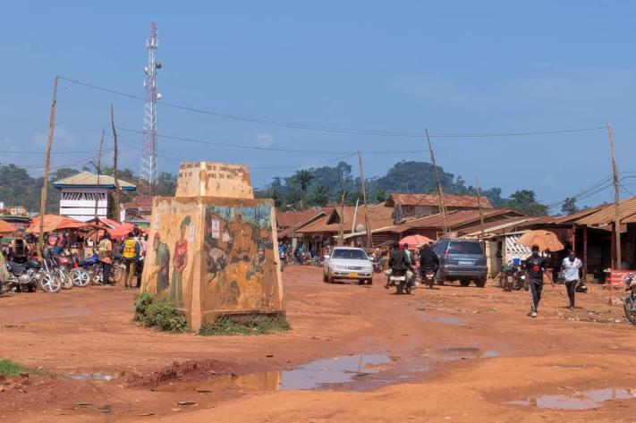
A tragic incident occurred on Monday, May 11, 2026 in the provincial sub-division of the EDU-NC Mambasa 1, in the territory of Mambasa, in the province of Ituri. Lightning fell on primary school 2 Tobola, a conventional Catholic school about 18 kilometers on the Kisangani road, causing the death of a student and several wounded.
According to information delivered by the Sub-Proved of Mambasa 1, the incident occurred in the morning during a heavy rain that affected the entire educational entity. A total of seven people were struck by lightning, including six students and one teacher.
Among the victims, one student did not survive after the tragedy, while the other five students and the teacher were admitted to a health facility in the square for appropriate care. Their state of health has not yet been officially communicated.
School authorities indicate that a delegation of educational management has been dispatched to the field in order to soak up the situation and provide the necessary assistance to the victims and the families concerned.
This tragedy revives concerns about the safety of learners in several rural schools in Ituri, often exposed to bad weather and devoid of lightning protection schemes.
The people of the region express their compassion for the affected families and call on the competent authorities to strengthen prevention measures in the province’s schools.

