**Lightning kills eleven stud bulls in Namibia - African Farming - Namibia**

<https://www.africanfarming.com/2025/05/01/lightning-kills-eleven-stud-bulls-in-namibia/>

1 May 2025  
  
***By Charl van Rooyen***

Lightning struck down eleven valuable stud bulls valued at approximately R1.2 million from the well-known Namibian Bonsmara breeder, Dr Joggie Briedenhann while sheltering under a thorn tree on his farm in Stampriet.

Briedenhann awarded the Southern African Stud Breeder of the Year in 2018, told *African Farming* that losing so many valuable bulls at once is a tremendous blow. Fortunately, the young bulls were not destined for this year’s production auction on 17 May at the farm; otherwise, he would have lost almost a quarter of the fifty bulls that would go under the hammer. Nevertheless, the bulls had already undergone performance testing and selection and would have been ready for the production auction next year.

The incident occurred on Sunday, April 27, while it was raining on the farm. When a herdsman did his daily rounds with a pickup truck to ensure all was well with the Bonsmaras, he missed some of the bulls, and when he went looking for them. He found the eleven bulls dead under a camel thorn tree. The force of the lightning bolt broke the tree in half. He informed Briedenhann’s son, Byron, who is farming on the farm, and he told his parents in Windhoek about their tremendous loss.

Dr Briedenhann estimates his damage, calculated by the average price of stud bulls at R112 000 from his seventeen production auctions since he began farming at Stampriet, to be around R1 232 000. Last year, however, his stud bulls sold for an average of R201 000, raising the estimated damage to a potential R2.2 million.

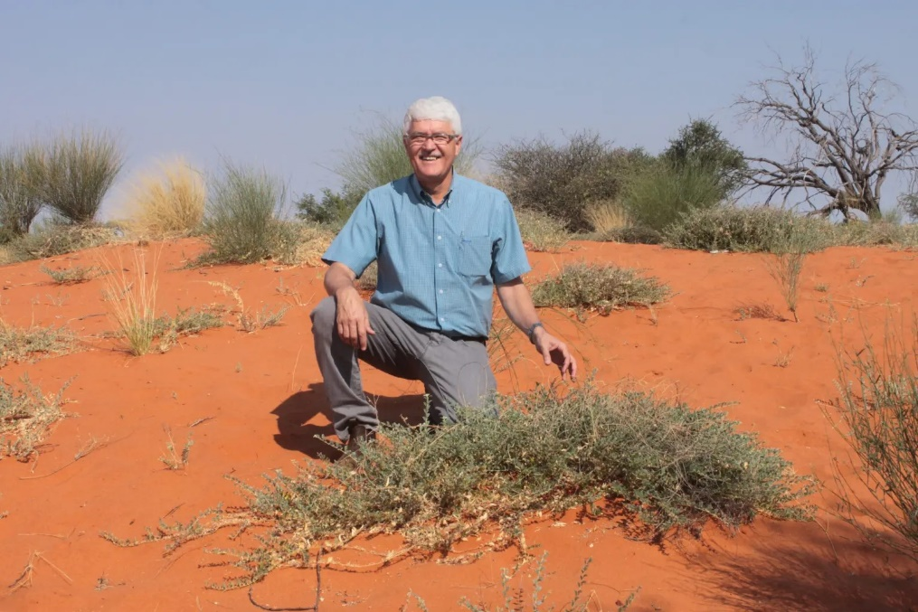

*Dr Joggie Briedenhann on a sand dune on his farm Hartebeestloop at Stampriet which is situated in the Kalahari Desert. Photo: Charl van Rooyen*

“This is a big blow, but sometimes life throws you an unforeseen curve ball you can’t do anything about. There was heavy rain, and the bulls were sheltering under a tree,” he said.

He had lost cattle to lightning before, but only a few were previously killed. This was his first significant loss due to lightning.