**SAD TRAGEDY!! Deadly Lightening Strike Leaves Many Ugandans Dead, Here Are The Details - Uganda**<https://www.kampalapress.com/news/sad-tragedy-deadly-lightening-strike-leaves-many-ugandans-dead-here-are-the-details/>

26 August, 2025

By Kampala Press Team

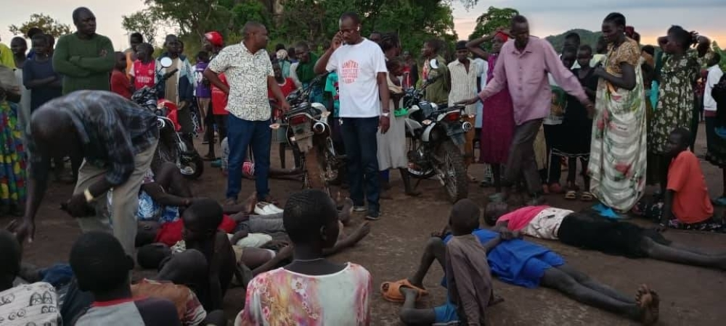

Tragedy struck Rwakashanga Cell in Rwahi Town Council, Ntungamo District, on the afternoon of 19th August 2025, when a sudden lightning strike claimed the lives of five people. The incident occurred at around 5:00 p.m. during a heavy downpour, leaving the local community in deep shock and mourning.

The victims included Taremwa Edgar, aged 38, Nduhukire Jackline, aged 44, and Mwaka Alexander, aged 25. Two other men, believed to be between 30 and 50 years old and residents of Ruhaama in Ntungamo District, remain unidentified. Four bodies have already been released to their families for burial, while the unidentified body is still at Itojo Hospital mortuary.

According to SP Kasasira Samson, the Police PRO for Rwizi Region, the tragedy began earlier that day when eight people went to work in gardens located in Ruhwabwoba and Kidede, both in Rwakashanga Cell. These individuals were engaged in digging and tending to the gardens when heavy rain began to fall in the evening.

The rain forced the group to seek shelter on the verandah of a nearby house, but unfortunately, the doors were locked. As they waited for the storm to pass, lightning struck the location, killing five people instantly. The suddenness of the event left those nearby terrified and unable to prevent the loss of life.

Community members rushed to the scene after hearing the thunderous strike and were met with a horrifying sight. Locals described the moment as “unimaginable” and said the incident has left a lasting emotional impact on the families and neighbors in Rwakashanga.

Authorities have urged residents to exercise caution during the ongoing rainy season, particularly when working outdoors. Lightning strikes have become a serious concern in the region, and officials recommend seeking safe shelter immediately when storms begin.

The Ntungamo District community is now mourning the loss of its residents. Funerals are being arranged for the identified victims, while authorities continue efforts to identify the remaining victim. This tragic event serves as a stark reminder of the dangers of sudden storms and the importance of taking weather warnings seriously.