**.Lightning Strikes Four Cows, Leaves Two Dead and Shepherd Injured – Uganda**<https://aclenet.org/news-publications/newsletters/newsletter-overview.html>

4 April 2025  
  
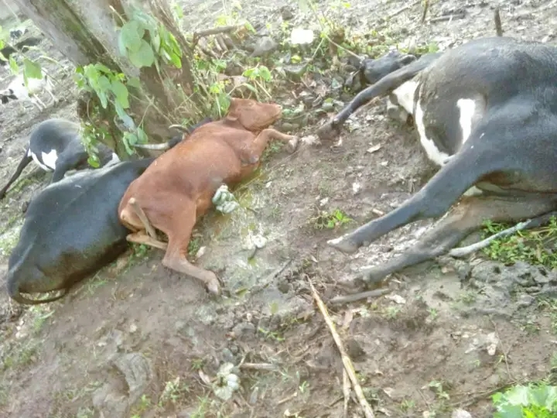

By Citizen Reporter, Bernard Manirakiza

A devastating lightning strike claimed the lives of two cows and left their shepherd in shock. The incident occurred behind Muramba Primary School in Burungu village, Muramba sub-county, when lightning struck a tree where the shepherd was grazing his four cows.

According to eyewitnesses, the lightning struck and killed the two cows instantly, leaving the shepherd in a severe condition. He was rushed to a nearby hospital where he received treatment and managed to survive.

The shepherd, who had acquired the cows as compensation for his years of service caring for other people's livestock, is still grappling with the loss of his valuable assets.

This is not the first time Muramba Primary School has been affected by lightning. In the past, the school has experienced similar incidents that resulted in loss of lives.

Credit: Our Citizen Reporter - Bernard Manirakiza- [bmanir2020@gmail.com](mailto:bmanir2020@gmail.com)