Masindi registers three cases of lightning strikes in three weeks – Uganda
https://ugreports.co.ug/masindi-registers-three-cases-of-lightning-strikes-in-three-weeks/
19 August 2025
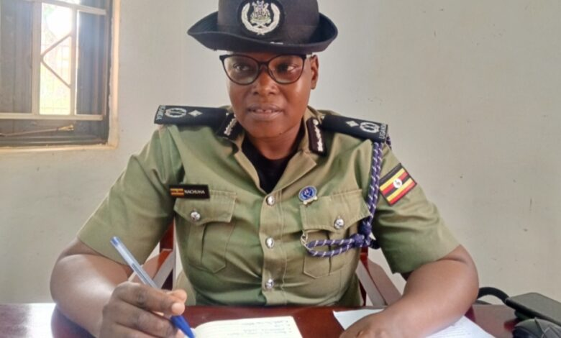
ACP Damalie Nachuha, the Regional Police Commander for Albertine North
By Innocent Atuganyira
Authorities in Masindi District have reported a worrying trend of lightning strikes over the past three weeks, resulting in multiple fatalities and injuries across the region.
According to Damalie Nachuha, the Regional Police Commander (RPC) for Albertine North, three separate incidents have been registered between July and August 2025, each resulting in tragic loss of life.
In the most recent case, on August 17, David Gahweera, a resident of Nyakarongo village, Kimengo Sub-county, was killed by lightning while gardening with his wife.
Police retrieved the body and took it to Masindi General Hospital for a postmortem.
A second incident was reported on August 8, 2025, around 7:45 PM at Bombo-Kibibira Market in Kiruli Sub-county, Masindi District. It is alleged that five people were killed and several others injured when lightning struck the market. However, detailed information was limited, as most of the victims had already been taken away by relatives before police arrived.

The third incident occurred on July 13 in Kyarutanga village, Kijunjubwa Sub-county, within the Royal Ranches. Four young people weeding a sugarcane plantation were killed, while eight others were injured.
The deceased were identified as Olegirwth aged 20, Bright Tekakwo 22, Jodan 19 and Brian male 18 years. The eitght who were injured are; Fred Male 25, Acen Consulate 24, Innocent Rwothmiyo 19, Noel Sunday 17, Oparwoth Byron 20, Opakrwoth Denis 17, Mungujakisa Clifort 19 and Ofoyorwoth Innocent 17.
RPC Nachuha is urging the public to take necessary precautions during rainstorms. She advises residents to stay indoors, avoid using electronic devices, and wear shoes to reduce the risk of being struck by lightning.

