Lightning Strike Kills 11 Animals in Nyimba – Zambia
https://www.lusakatimes.com/2026/03/31/lightning-strike-kills-11-animals-in-nyimba/
31 March 2026
By Guest Editor
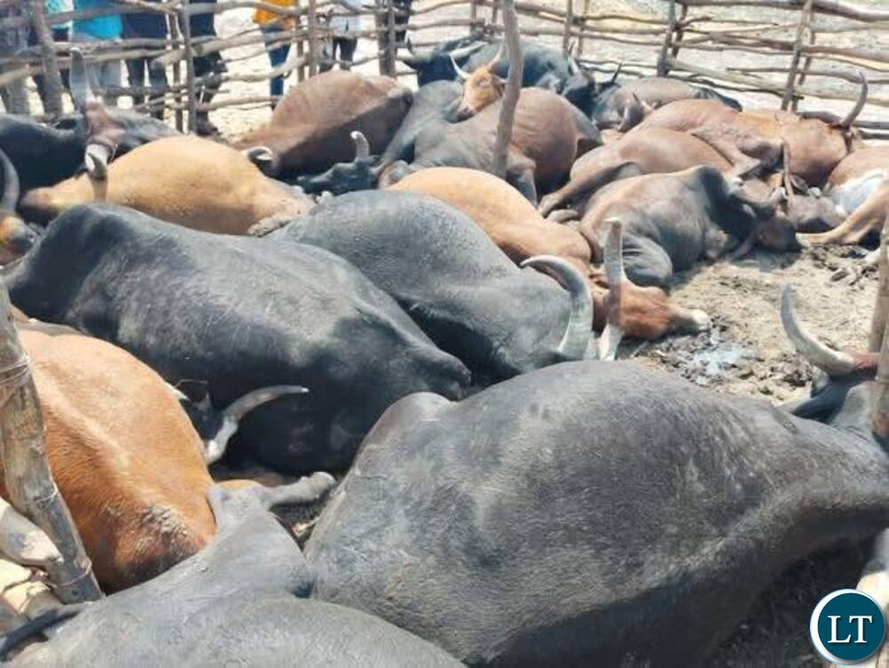
Eleven animals valued at K71,500 have been killed by lightning in Nyimba District in Eastern Province.
The incident occurred in Kamponi Village under Chief Ndake at around 15:40 hours, according to Eastern Province Police Commanding Officer Robertson Mweemba.
Discover more
Breaking news notifications
Investigative journalism reports
Legal consultation services
Mr Mweemba said the animals belonged to Fackson Daka, who had reportedly secured them in a kraal before leaving for his home.
However, shortly after, the area experienced heavy rainfall accompanied by a powerful storm and intense lightning, which struck and killed the animals instantly.
The development comes barely a day after a 15-year-old girl tragically lost her life due to a lightning strike in the same district.
Following the incident, relatives of the livestock owner moved in to dispose of the carcasses.

