**DRC 2024 - Idjwi: Heavy rain causes death of woman and several damages**

https://lapresseafricaine.net/article/idjwi-une-forte-pluie-cause-la-mort-d-une-femme-et-plusieurs-degats/231

12 April 2024

After heavy rains that fell on this part of the Idjwi territory on the evening of April 9, 2024, the Mpene group in the Ntambuka chiefdom suffered material and human damage.

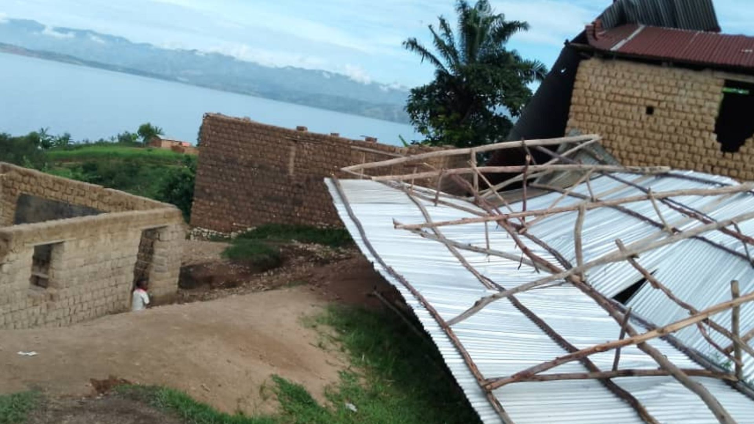

According to Amos Buyeye, who informed the African press this Friday, April 12, the rains caused the death of a mother named Cheka Hategeka from the village of Muhyahya, mother of 4 children, who had been struck by lightning in her home.

A strong wind caused the destruction of the Antiokia primary school of the 8th Cepac Chamahiri during this same rain.

Our source deplores the fact that more than 240 students are forced to stay at home during this last term.

The Mpene civil society group is calling on the authorities and people of goodwill to help the affected family and the school that was hit by this disaster.

Richelieu BYAMANA/ LPA-Idjwi

Report courtesy DRC citizen reporter network through Jacques KAMBETI MASUMBUKO for ICCOD ONG [ongiccod@gmail.com](mailto:ongiccod@gmail.com)