Shock in Agago as Lightning Strikes Dead S.4 Student and Young Girl Under Tree - Uganda
https://amolatarpost.com/2026/05/07/shock-in-agago-as-lightning-strikes-dead-s-4-student-and-young-girl-under-tree/
By Lazarus Odongo
7 May 2026

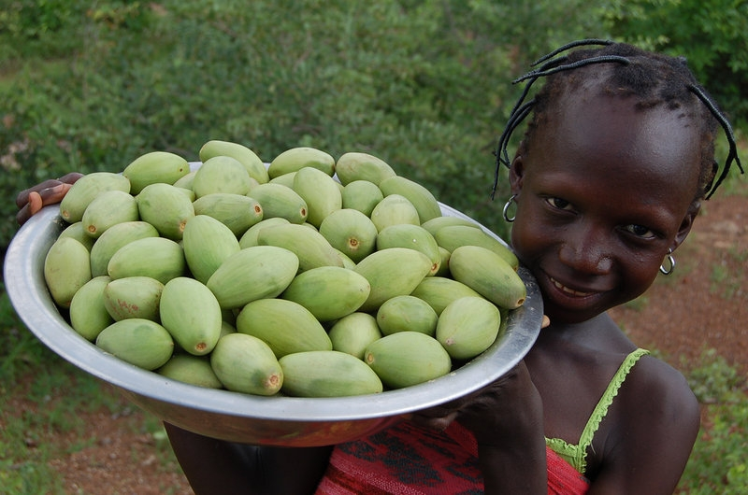
Agago District,Uganda | Tragedy has struck after two young people lost their lives when lightning struck them during a heavy rainstorm while harvesting shea nuts, commonly known locally as “Yaoo.”
The deceased, identified as a Senior Four student and a young girl from the district, had reportedly gone to collect shea nuts in the bush when dark clouds gathered and heavy rains suddenly began pounding the area.
According to eyewitnesses and local residents, the two attempted to seek shelter under a giant shea nut tree to escape the downpour, unaware of the danger posed by thunderstorms. Moments later, a powerful lightning strike hit the tree, killing both victims instantly.
Residents who rushed to the scene found the two lying motionless beneath the tree. Despite efforts to respond quickly, the victims had already succumbed to the electric shock.
The tragic incident has plunged the community into mourning, with relatives, friends, and residents expressing deep sorrow over the sudden loss of the young lives. The boy was buried on May 5, while burial ceremonies for the young girl are taking place today, May 7.
Local leaders say the tragedy should serve as a serious warning to communities about the dangers of taking shelter under large or isolated trees during thunderstorms. They noted that many rural residents, especially farmers and children working in gardens, often unknowingly expose themselves to deadly lightning strikes during rainy seasons.
Community elders and authorities in Agago have since launched awareness messages urging residents to immediately leave open fields and avoid trees whenever storms begin. Experts explain that tall trees are highly vulnerable to lightning because they naturally attract electrical discharges from storm clouds.
Residents also highlighted the lack of safe shelters in farming areas, saying many people are left with no option but to hide under trees whenever rain starts unexpectedly. Shea nut harvesting remains a major economic activity for many families in Northern Uganda, especially women and children who spend long hours in the fields collecting the nuts for food and income.
Leaders are now calling upon schools, churches, local governments, and disaster management officials to intensify public sensitization campaigns on lightning safety and emergency preparedness during the rainy season.
Uganda has over the years recorded multiple lightning-related deaths, particularly in rural districts where people frequently gather in open spaces or under trees during storms. Weather experts continue to advise the public to seek shelter inside permanent buildings and avoid open fields, water bodies, and tall objects whenever thunderstorms occur.
The heartbreaking deaths in Agago have left the community shaken, with many residents describing the incident as a painful reminder of the increasing dangers associated with extreme weather conditions.

