Lightning strikes kill one person, injures three during KZN storm – South Africa
https://www.timeslive.co.za/news/south-africa/2026-02-09-lightning-strikes-kill-one-person-injures-three-during-kzn-storm/
9 February 2026
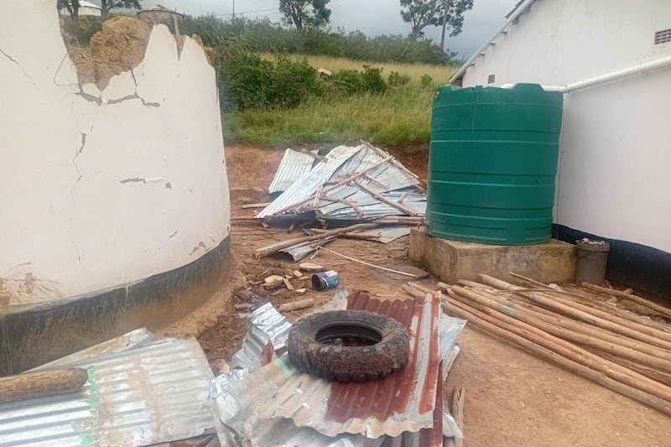
Disaster management teams have been deployed to the Harry Gwala and uMgungundlovu municipalities after a weekend of destructive weather left one person dead and dozens homeless.
By TimesLIVE
KwaZulu-Natal co-operative governance and traditional affairs MEC Thulasizwe Buthelezi said the severe weather which began on Friday and continued through to Saturday, saw gale-force winds and hailstorms sweep through the region.
In Umzimkhulu, a ward 15 resident was struck and killed by lightning while at work on Friday.
In a separate incident in ward 12, three people sustained injuries from lightning strikes and are receiving medical attention.
Dozens of people were left homeless after gale-force winds in parts of KwaZulu-Natal at the weekend. (COGTA)
The impact across the affected districts is:
- ⁠uMgungundlovu district (Impendle local municipality): in Ward 5, 12 households, including 18 children and two senior citizens, were severely affected. Seven homes were completely destroyed, leaving four families destitute. Cogta, in collaboration with the social development department, distributed food parcels, blankets and hygiene kits.
- ⁠Harry Gwala district: in addition to the casualties in Umzimkhulu, preliminary reports indicate at least 11 homes across the district have been damaged by hail. A significant rockfall in ward 1 obstructed road access, which disaster teams are working to clear to ensure aid reaches remote areas.
“Our priority is the safety and dignity of those who have lost everything in the storms. We are fast-tracking the provision of building materials and temporary shelter to ensure no family is left exposed to the elements. We remain in a state of high alert.”

