Guinea - Ninguètèè (Pita): A mother, her son and her grandson... killed by lightning
https://www.africaguinee.com/ninguetere-pita-une-mere-son-fils-et-son-petit-fils-tues-par-la-foudre/
20 June 2026
By bMamadou Yaya Bah
PITA – A violent love at first sight claimed the lives of three members of the same family in the locality of Bhoundou Haïrè, district of Ninguètèè, under the sub-prefecture of Sangaréah, in the prefecture of Pita. The tragedy occurred in the afternoon of Friday, June 19, 2026 while the victims were in a field in full agricultural activity. According to the information gathered, the victims are Aïssatou Diallo, mother of six children, his son Thierno Mayatou Diallo, only two years old, as well as his grandson Abdourahmane Diallo, aged six.
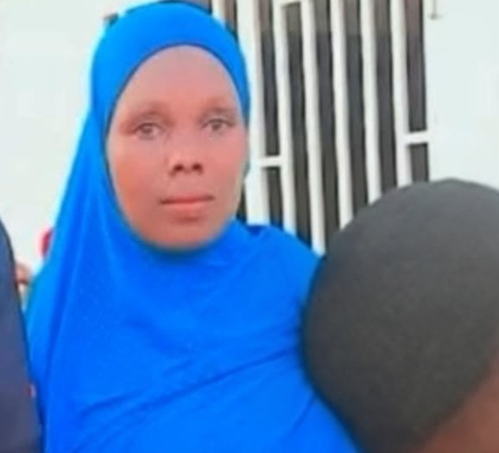
Aïssatou Diallo
Contacted by phone by our editorial staff, a local citizen, Ismaël Bah, returned in detail to the circumstances of this tragedy that plunged the whole community into dismay.
“As usual, the members of this family had left very early in the morning in their field to carry out the ploughing work. The day went normally until the end of the afternoon. At one point, Aïssatou Diallo had asked his daughter to leave the field in order to go home to prepare the evening meal. A part of the group has therefore returned, while she herself has remained on the spot with other people to continue the agricultural work,” he explained.
Continuing his story, our interlocutor explains that the situation abruptly changed when the first rains were announced in the area. “Around 17 hours, the weather began to deteriorate and heavy rain fell on the area. Faced with this situation, Aïssatou Diallo, his child and grandson, as well as other people in the field, looked for a place to take shelter. It was at this moment that a violent lightning with a lightning strike fell on them. Unfortunately, Aïssatou Diallo, his son Thierno Mayatou Diallo and his grandson Abdourahmane Diallo lost their lives on the spot even before the rescue arrived. The other people present had a shock following this dramatic scene,” he said.
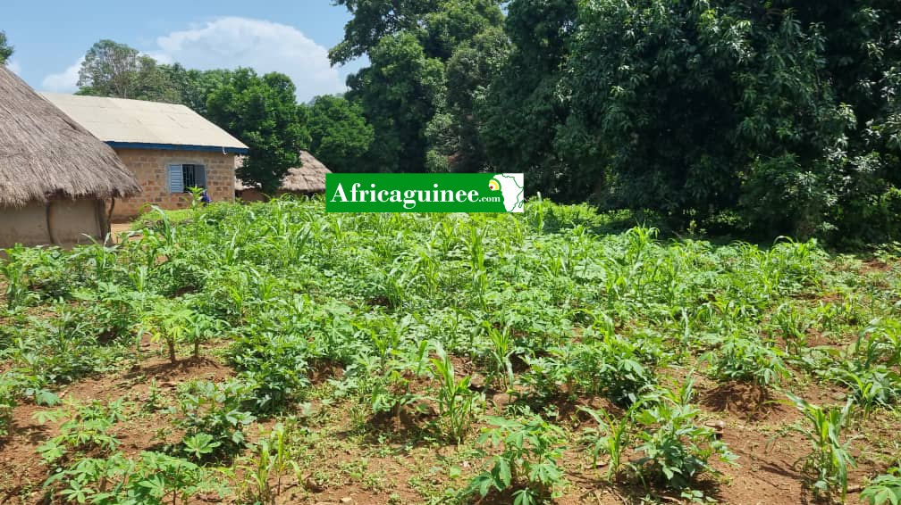
According to several testimonies gathered, the news of the tragedy quickly spread to the surrounding villages, causing a strong emotion among the populations of this part of the prefecture of Pita.
“As soon as the information was known, the residents mobilized to go to the scene of the tragedy. The bodies of the victims were recovered and then transported to the village. The pain is immense because they are three members of the same family taken away at the same time. The whole community is in shock and shares the grief of the bereaved family,” added Ismaël Bah.
The remains of the three victims were buried this Saturday, June 20, 2026 in their locality of origin, in Ninguètèrè, in accordance with religious and customary rites. This tragedy comes in the middle of the rainy season, a period during which the risks associated with thunderstorms and lightning are particularly high in several parts of the country.

