Land authority reassures Rusizi residents after lightning strikes damage key station – Rwanda
https://www.newtimes.co.rw/article/29168/news/land-authority-reassures-rusizi-residents-after-lightning-strikes-damage-key-station
25 August, 2025

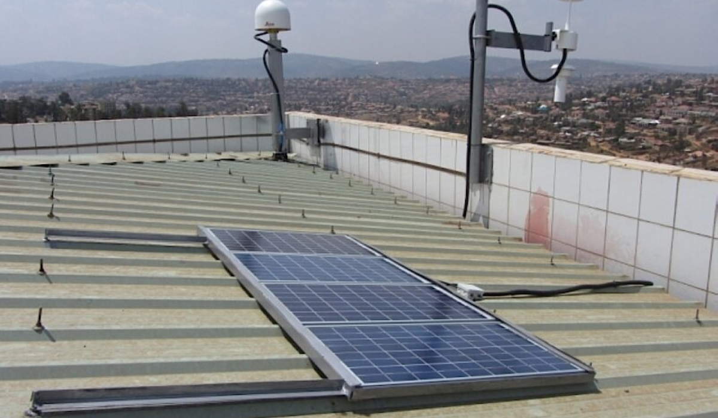

By Michel Nkurunziza
The National Land Authority (NLA) has reassured residents of Rusizi District that the local station for land surveying services that was recently damaged by lightning strikes will be repaired by September.
For the past two months, local residents have not been able to access land surveying services due to a lightning strike that hit one of 10 Continuously Operating Reference Stations (CORS) used for data collection in these services across the country.
“We are still working on the reparation of the damaged station that was used for data collection in land surveying services,” Marie-Grace Nishimwe, NLA Director General and Chief Registrar of Land Titles told The New Times on Monday, August 25.
Nishimwe said the lighting strikes caused damage to the server room other equipment.
“We began by replacing the damaged equipment, but repair work is still ongoing and is expected to be completed by September,” she said.
The stations provide real-time data for high-precision land surveying services.
Part of a system called Rwanda GeoNet, the special stations set up in different parts of the country constantly receive signals from satellites (like GPS).
Rwanda GeoNet is a sophisticated system that provides high-precision positioning and geospatial information used for applications across surveying, meteorology and geophysics across the country.
Which land services have been affected?
The affected services include land subdivision, land boundary identification, land transactions, and property valuation.
“When the station is not functioning, you can’t get high-precision measures. It can lead to errors in land demarcation and others,” Jean Marie Vianney Muhawenimana, a land surveyor based in Rusizi, told The New Times.
“We have temporarily halted operations, which is affecting our businesses to provide the services. We refer to the station in land surveying for those seeking transfer or registering, those who need construction permits, those building roads, those rectifying land demarcation errors, among others.”
Since the beginning of 2025, Rusizi District has recorded more than 6,000 land-related services.
These include 2,714 transfers by voluntary sale, 2,323 for subdivision services, 565 boundary rectifications, and some 287 for sporadic registrations.

