Lodja: Lightning kills one and injured in Ndjili neighborhood - DRC
https://rtnc.cd/lodja-la-foudre-fait-un-mort-et-une-blessee-au-quartier-ndjili/
10 September 2025
By Redaction
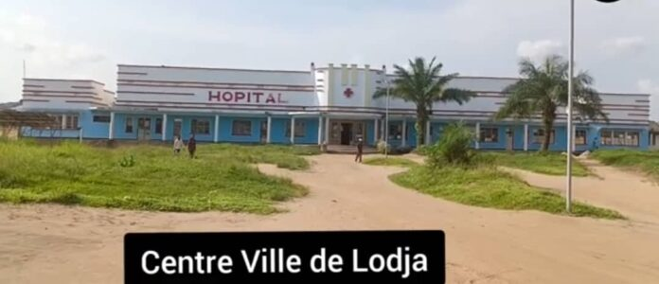
Two women were struck down on Wednesday, September 10, 2025 in downtown Lodja, precisely in the Ndjili district.
The one unfortunately lost his life immediately while the other was seriously injured and transferred urgently to the Lodja Reference General Hospital.
According to the testimonies gathered, the two victims were outside when a violent storm fell. The discharge was so brutal that the first woman did not survive.
“These no longer come only to water the earth, they often leave behind them damage either human or material” is indignant a resident
It should be noted that these bad weather has recently caused several material damage in the city center of Lodja and Tshumbe.
Jean-Claude Kopami Shongo, from Sankuru

