Catastrophic lightning strike damages cars, injures child at God’s Window – South Africa
https://www.citizen.co.za/lowvelder/news-headlines/local-hard-news/2025/10/12/catastrophic-lightning-strike-damages-cars-injures-child-at-gods-window/
12 October 2025
By Bertus de Bruyn
A powerful lightning strike at the popular God’s Window viewpoint has resulted in property damage and injury, according to eyewitness reports.
The incident, which occurred on Friday, October 10, left 15 vehicles severely damaged and a child hospitalised.
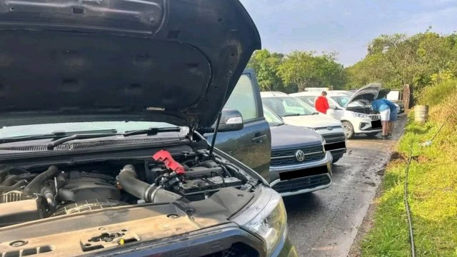
Some of the cars that were damaged by the lightning.
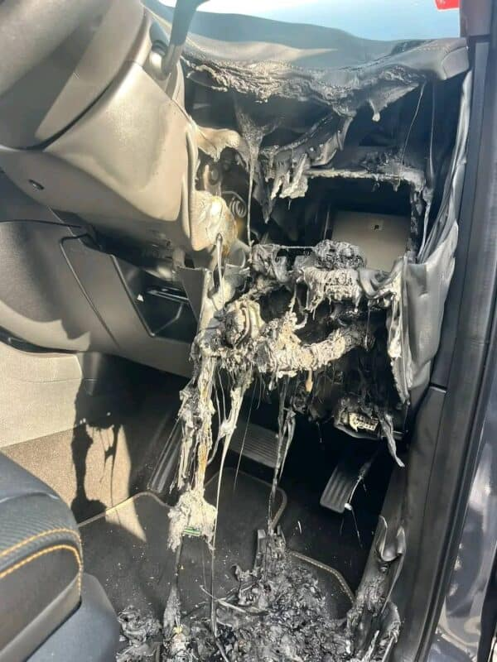
The event unfolded rapidly, with eyewitnesses estimating that the entire incident lasted less than five minutes. During this brief but terrifying moment, lightning struck the area, causing chaos among the parked cars.
The impact of the lightning strike was immense, leaving 10 vehicles with burst tires. In one instance, a vehicle reportedly caught fire after being struck.
Amid the property damage, a child was injured during the incident and was rushed to hospital for further medical attention. No details about the child’s condition have been released at this time.
Thomas Msiza, spokesperson for the Mpumalanga Tourism and Parks Agency, confirmed that they are aware of the incident.
He said officials are currently gathering more information and assured the public that further details will be released in due course.
This is a developing story. Lowvelder will update its readers once more information becomes available.
At Caxton, we employ humans to generate daily fresh news, not AI intervention. Happy reading!
Tumelo Waga Dibakwane
Tumelo Waga Dibakwane is a seasoned journalist, who started his career in 2012. He is actively involved in a variety of socio-economic stories that affect communities in the Lowveld at a grassroots level. He has have covered a myriad of stories, some of which have highlighted the plight of township and village life.

