Lightning strike kills SSPDF soldier, injures two in Rumbek East – South Sudan
https://www.radiotamazuj.org/en/news/article/lightning-strike-kills-sspdf-soldier-injures-two-in-rumbek-east
23 May 2026
by Editor In Chief
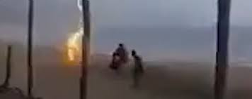
RUMBEK EAST
Authorities in Rumbek East County in Lakes State said a lightning strike killed a soldier from the South Sudan People’s Defence Forces (SSPDF) and injured two other people during heavy rain on Thursday.
The incident occurred in Maborduang village in Rumbek East County, local authorities said.
Rumbek East County Commissioner Malual Anyuon told Radio Tamazuj on Friday that the lightning strike hit during a rainstorm on Thursday afternoon.
“A similar incident happened last year in the Akot area, and again this year in the same part of Rumbek East County,” he said.
Anyuon urged residents to remain vigilant during heavy rains and thunderstorms, advising people to avoid unnecessary movement and to switch off mobile phones during severe lightning.
He said residents should seek shelter immediately when lightning intensifies.
Mabor Dhieu, the owner of the house struck by lightning, said one person was killed while two others, a woman and a child, survived with injuries.
“The lightning strike burned the entire tukul and destroyed property. Only a few items were left undamaged,” he said.

