Côte d’Ivoire-AIP/ A tornado kills two people and damages homes in Zankagleu
https://www.aip.ci/338292/c-20/
25 March 2026
By DELPHIN EHUI
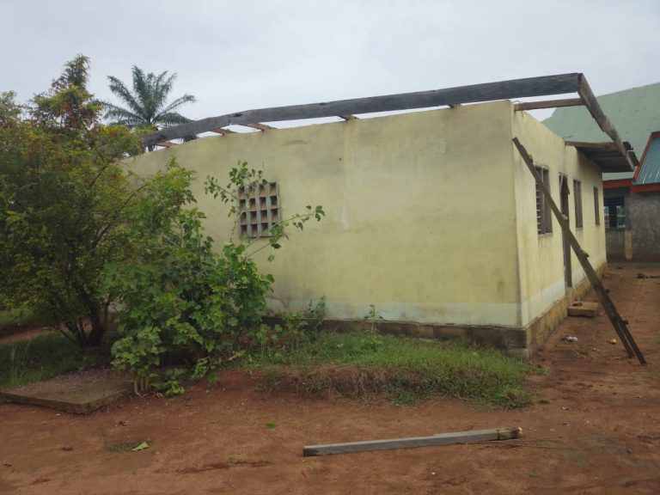
The home of the pastor of the UEESO church in Kouan-Houlé was not spared by the tornado.
Danané, March 25, 2026 (AIP)-A tornado occurred Tuesday, March 24, 2026 in Zankagleu, in the sub-prefecture of Kouan Houlé (in the department of Danané), has left two dead and damaged homes.
In this village on the edge of the international road leading to Guinea, two teenagers lost their lives. It is about K. D. Ezekiel, 14 years old, and B. J. Marc, 16, all students at the Zingbé Mathias High School in Danané.
According to Mr.'s testimony Oulai Barthélémy, the events occurred between 4 p.m. and 5 p.m. while young people were playing ball. A tornado came out, followed by thunder and lightning falling in the middle of the playground. Many young people have lost consciousness. The two students did not regain knowledge.
In the city of Kouan Houlé, the home of the pastor of the UEESO community has been decomposed.
The populations of the localities concerned report loss of life and property damage after the passage of the tornado.

