Thunderstorm Claims Two Lives, Leaves Two Hospitalized In Obi, Nasarawa – Nigeria
https://www.gistmania.com/talk/topic,622131.0.html
12 June 2025
By Mister Jay Wonder

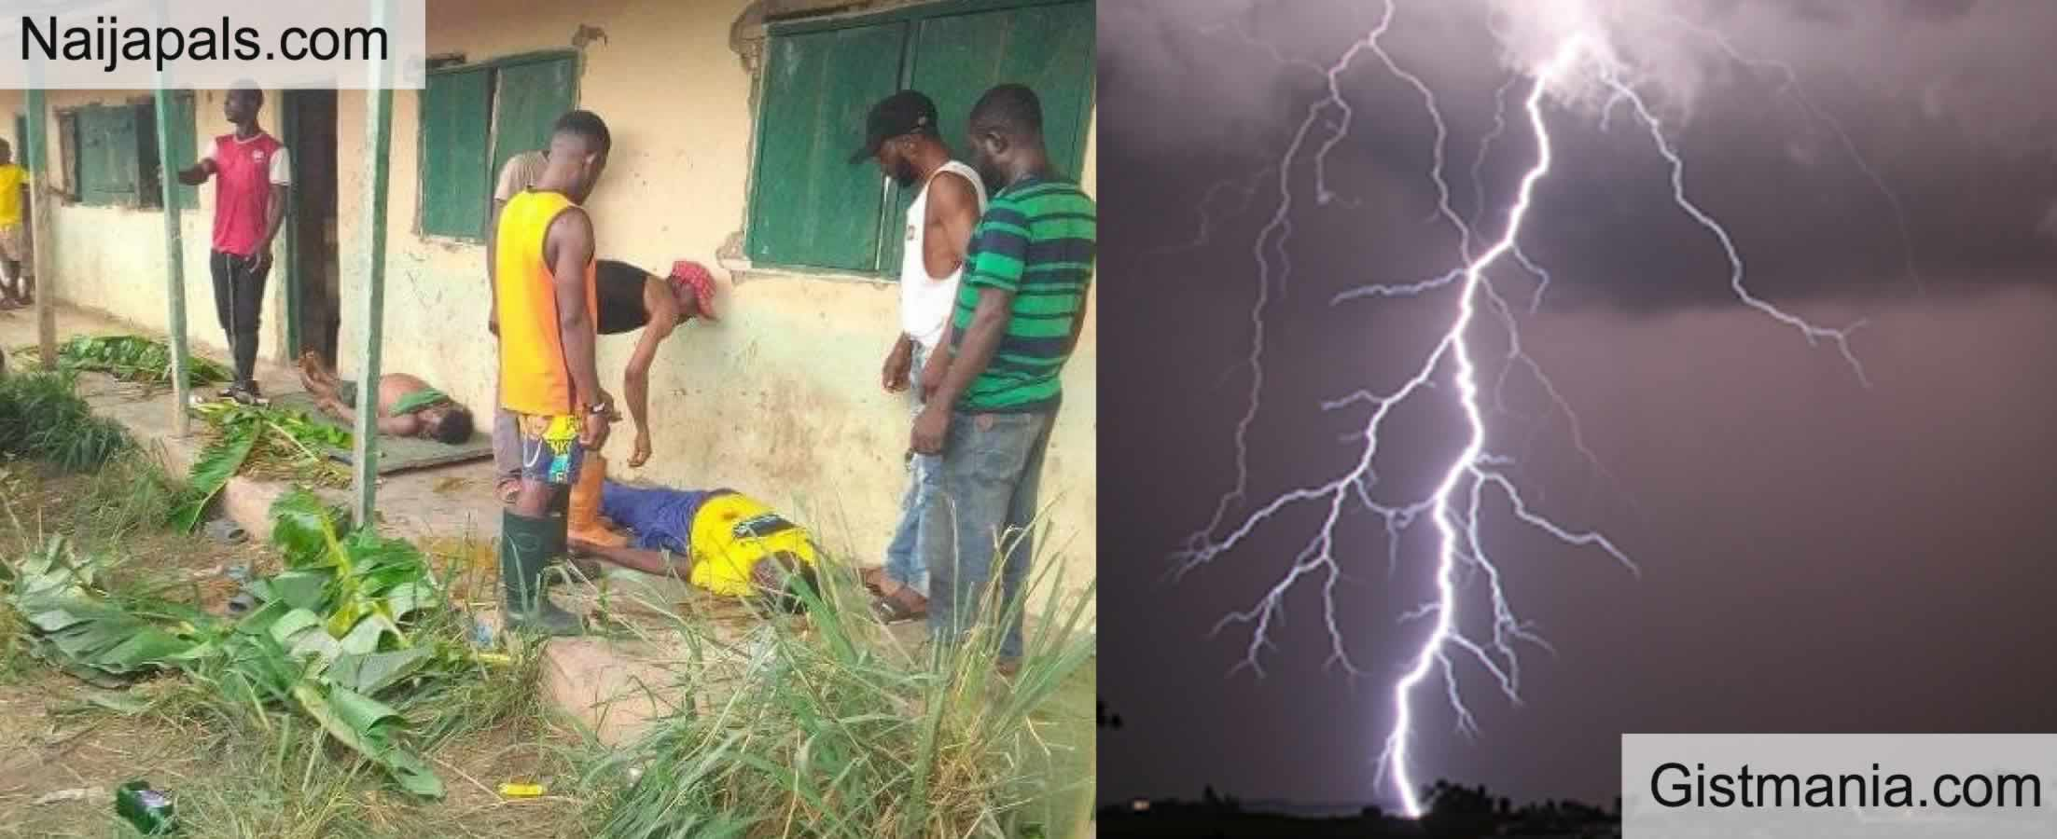
A sudden thunderstorm turned deadly in Obi town on Monday as a lightning strike claimed the lives of two young men and left two others battling for survival.
The victims, identified as Aminu Amegwa Ayitogo and Micah Christopher, were reportedly taking refuge from a heavy downpour under a makeshift motorcycle workshop shade situated directly opposite the Obi Local Government Secretariat when disaster struck.
Eyewitnesses described a horrifying scene, stating that a deafening thunderbolt hit the group without warning, instantly killing Ayitogo and Christopher on the spot.
Two others — Bulus Ogu Iwala and Abraham Francis Tarkaa — sustained severe injuries from the strike and were rushed to the Federal University Teaching Hospital in Lafia. Medical sources say both remain in critical condition as doctors work to stabilise them.
The incident has sent shockwaves through the Obi community, prompting urgent warnings from local officials. Authorities are advising residents to avoid open areas, tall trees, and metal structures during thunderstorms, citing the increased risk of lightning-related fatalities.
“This tragedy is a painful reminder of the dangers posed by severe weather. We urge everyone to take extra precautions during storms,” a local government spokesperson said.
With the rainy season intensifying across the region, weather experts and emergency services are calling for heightened public awareness and safety measures to prevent further casualties.

