BOVINE SINISTER IN NIKKI: Four oxen killed by lightning during a violent storm - Benin
https://agri-impact.bj/2026/04/25/sinistre-bovine-a-nikki-quatre-boeufs-tues-par-la-foudre-lors-dun-violent-orage/

25 November 2026

By Agriimpact

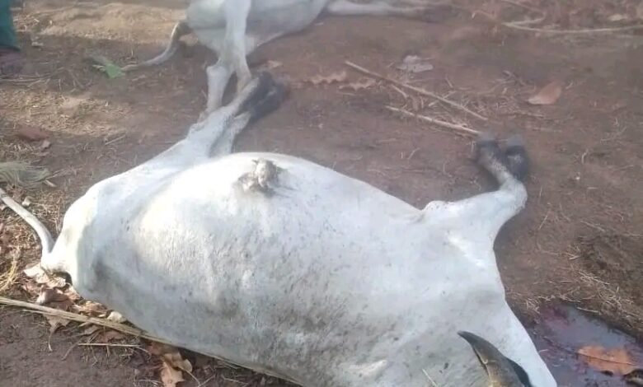
A stormy rain that occurred on the evening of Saturday, April 18, 2026 caused a tragedy in northern Benin. In the hamlet of Gnel-Keridji, under the town of Fombawi in the district of Ouénou, a commune of Nikki, four oxen were struck down, causing a heavy loss for their owner.
According to information relayed by the radio Su Tii Dera, the animals belonged to the same breeder, now facing significant economic damage. The incident occurred following a heavy electric shock during the storm, a natural phenomenon that was particularly dangerous for grazing animals, exposed in open ground.
After their death, the oxen were slaughtered, a practice that raises questions among the local population. Several inhabitants are indeed wondering about the fate of the meat from these animals: will it be consumed by the owner or introduced into the marketing circuits? This raises public health concerns, including potential risks related to the consumption of meat from animals that died in such conditions.
In the face of these concerns, the veterinary services were quickly seized. The latter have taken steps to assess the situation and ensure the health security of the population. Their intervention aims in particular to determine whether the meat is specific to consumption and to prevent any risk of contamination.
This tragedy highlights the vulnerability of pastoralists to climatic hazards, which are increasingly frequent in some regions. It also recalls the importance of meeting health standards for the management of animal carcasses in order to protect the health of consumers.

