**Masaka officials direct schools to install lightning arrestors after tragic incident - Uganda**

<https://www.monitor.co.ug/uganda/news/national/masaka-officials-direct-schools-to-install-lightning-arrestors--4990834>

4 April 2025

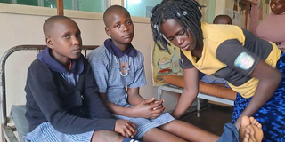

Pupils struck by lightning at Sserinya Primary School were recovered and discharged from St. Joseph Kitovu Hospital in Masaka on April 3, 2025. PHOTO BY ISSA ALIGA

By Issa Aliga

Masaka City Principal Education Officer, Mr Stephen Kakeeto, has directed all schools—both private and government-aided—to install lightning arrestors as a preventive measure against lightning strikes during heavy rain.

The directive follows a tragic incident on Wednesday, April 2, when a lightning strike killed a teacher identified as Moses Mutaawe at Sserinya Primary School in Bulando Parish, Nyendo-Mukungwe Municipality, Masaka City. Mutaawe passed away shortly after arriving at St. Joseph Hospital, Kitovu.

In addition, eight pupils and two teachers, including Ms Rose Nakkazi and Head Teacher Ms Florence Nambalirwa, were rushed to the same hospital after suffering paralysis in their limbs. Fortunately, the eight pupils have shown steady improvement and have been discharged, while the two teachers are still undergoing treatment.

[[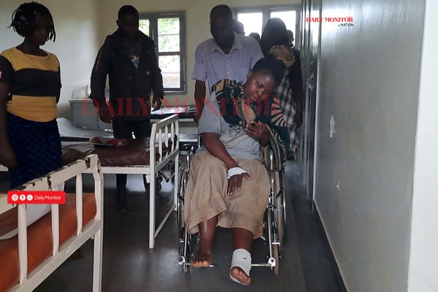](https://www.monitor.co.ug/uganda/news/national/lightning-kills-teacher-injures-head-teacher-and-15-pupils-in-masaka-4988050)](https://www.monitor.co.ug/uganda/news/national/lightning-kills-teacher-injures-head-teacher-and-15-pupils-in-masaka-4988050)

According to Mr Kakeeto, it will be considered negligence if school administrators fail to install lightning arrestors, which are crucial to saving the lives of both students and teachers in the event of thunderstorms and lightning.

“Masaka City has 304 primary schools, twelve secondary schools, two technical institutions, and three teacher training colleges, but very few of these schools have lightning arrestors installed on their classroom blocks. All schools without these devices will be closed if they fail to comply because we cannot sit back when the safety of learners is at risk,” Mr Kakeeto stated in an interview on Friday.

Lightning arrestors are designed to intercept, conduct, and divert excess energy to the ground, protecting classroom buildings and equipment from damage.

Mr Kakeeto also expressed concern over a dangerous practice in some schools with nursery sections, where children are forced to remove their shoes during lessons and leave them outside to avoid dirtying tiled classrooms.

“This practice puts children at risk if lightning strikes. Barefoot children in tiled classrooms are more vulnerable to being struck by lightning, and such schools must stop this practice immediately,” he warned.

Additionally, Mr Kakeeto cautioned teachers against entering classrooms with mobile phones during rainstorms, as phones can attract lightning strikes, endangering students.

Some parents have welcomed the directive, saying their children will be safer if schools install lightning arrestors.

Mr Teddy Namukasa, a resident of Sserinya Village in Masaka City, has urged other parents and local leaders to monitor all schools to ensure compliance. He emphasized that parents should not send their children to schools that fail to install the necessary safety measures.

Mr Twaha Kasirye, the Masaka Regional Police Spokesman, confirmed that the postmortem report revealed Moses Mutaawe’s death was caused by lightning.

“The directive from the Masaka City education office is a good move, and police are ready to assist the education department in enforcing this directive against schools that do not have lightning arrestors,” he said.