Analavory: Lightning kills two people and one injured – Madagascar
https://midi-madagasikara.mg/la-foudre-fait-deux-morts-et-un-blesse/
28 January 2025
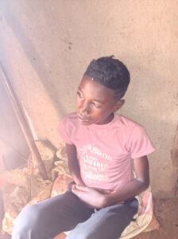
Two teenagers lost their lives and another was injured after being struck by lightning on Saturday, January 25, 2026 at around 4 p.m., while they were guarding oxen in Atsimon’ny tannan’Anosivola, fokontany of Aminaviavy, rural commune of Analavory, district of Miarinarivo. An ox also perished in this incident. Alerted in the morning of Sunday, January 26, 2026, around 11 a.m., the territorial brigade of Analavory went to the scene.
A team composed of three gendarmes, led by a senior-class gendarme, was accompanied by the medical staff of the CSB II of Analavory as well as representatives of the commune, under the direction of the first deputy mayor. Upon their arrival, the authorities observed the presence of two bodies without life, placed on a table at the home of Razafimahandry Pascal, father of one of the victims. The medical examination revealed a visible burn in one of the victims, while no apparent injuries were found on the other body. As for the injured teenager, he complained of pain in the stomach and back, without visible external injury.
The victims who died are 18-year-old Randrianasoloniaina Marc and 14-year-old Ndimbiarisoa Mamitiana. The injured man is identified as Tolotriniaina Fanomezantsoa, 16 years old. All are domiciled in Anosivola, within the same municipality. After the findings and medical examinations, the local authorities offered their condolences to the bereaved families. The support of the remains was entrusted to the relatives.

