Drama in Akanda: A family devastated by lightning on New Year's Eve – Gabon
https://gabonofficiel.com/drame-a-akanda-une-famille-devastee-par-la-foudre-lors-de-la-nuit-du-nouvel-an/
6 January 2026
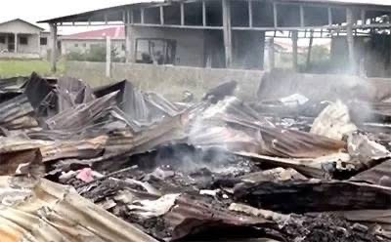
By Gabon Official
While Gabon was celebrating the arrival of the new year, sad news struck Akanda, north of Libreville. On the night of December 31, 2025 to January 1, 2026, a violent fire caused by lightning completely destroyed a family’s home, leaving them homeless or property.
According to witnesses, a lightning strike just before the rain triggered the disaster. Within minutes, the fire spread with frightening speed, consuming everything despite the efforts to contain the flames. The storm even damaged the electric meters of the neighbors, recalling the dangers of heavy rains accompanied by lightning.
Among the victims, two pregnant women, one of whom is close to childbirth, lost everything, including the baby’s keychain. His 15-year-old daughter, a second-class student, saw her notebooks, uniforms and school supplies go up in smoke.
The future mother, upset, launches an appeal:
“May God touch the hearts of good people so that they may help us. »
Today, this family finds itself without anything, facing a tragic beginning of the year. A call for national solidarity is launched to allow the high school student to return to school and offer future mothers a dignified welcome for their children.
This incident recalls the vulnerability of the population to the vagaries of climate and the importance of citizen solidarity in these difficult times

