**Lightning strikes kill 32 cows worth N100m in Ogun – Nigeria**

<https://punchng.com/lightning-strikes-kill-32-cows-worth-n100m-in-ogun/>

23rd June 2025

By Taiwo Bankole

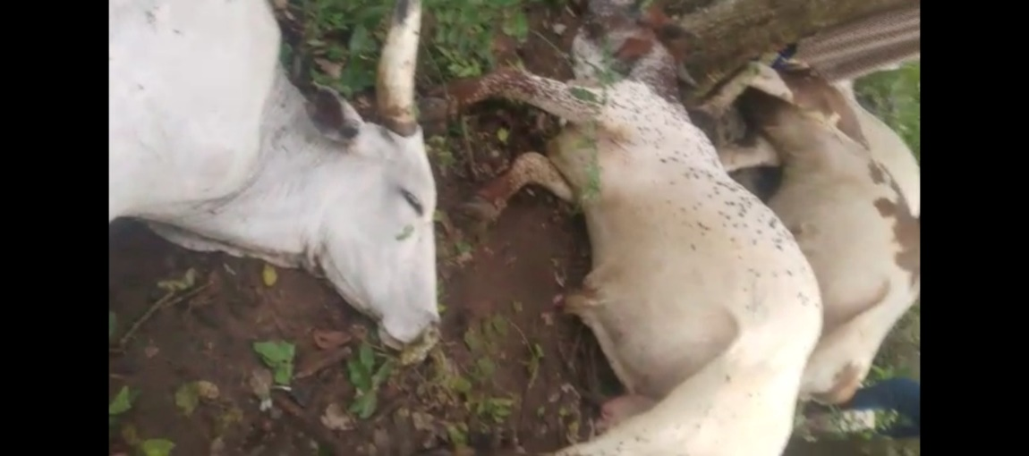

*The dead Cows. Credit: Bankole Taiwo*

The Baale of Osara, Obantoko, Abeokuta in Odeda Local Government Area of Ogun State, Chief Wasiu Afolabi, on Sunday, told *PUNCH Metro* that the worth of the 32 cows killed by thunder and lightning during Saturday’s downpour is about N100m

Chief Afolabi also said given the circumstances surrounding the death of the cows, some Sango priests would come around on Monday (today) to perform some rituals and appeasement after which the corpses of the animals would be buried and supervised by the officials from the state government.

The community leader disclosed this while speaking with our correspondent on Sunday.

Meanwhile, the elder brother of the owner of the cows, Hassan Momodu, in a phone conversation with our correspondent, on Sunday, pleaded for the support of the state government to recover from the losses suffered

Momodu, who hailed the state government and the police for the steps taken so far over the incident, however, added that the natural disaster left his brother with nothing to cater for his family and about 20 others who feed from the cow business.

He said, “The owner of the cows is my younger brother. He is the breadwinner of the family. Aside from his family members, there are more than 20 people who also feed from this business but he has lost everything.

“The market value of these animals is almost N100m. So, we are only begging the government to see whatever it could do to help this young man get back to business. We have all agreed that it is a natural disaster but with the government’s support the pains could be alleviated”.

However, Afolabi said that the Fulani herders who owned the cows, as well as the community members, had met with the police on Sunday to discuss the way forward, manage the tragic incident and ensure that the peace of the community was not hurt in any way.

He added that the Speaker of the state House of Assembly, Daisi Elemide and Chairman of Odeda Local Government, Dr Afolashade Adeyemo, had also visited the community to sympathise with the Fulani herders.

Afolabi said, “We are just finishing meeting with the police and the Fulani herders were also there. The corpses of the animals will be buried by the sanitary officers from the local government on Monday after the Sango priests would have performed the usual rites and rituals. The community will shoulder the financial burden of these rites.

“The Speaker of the Ogun State House of Assembly, Daisi Elemide and the Chairman of Odeda Local Government, Dr Afolashade Adeyemo, have also come around for an on-the-spot assessment and to sympathise with the Fulani herders.

“The cost of the dead cows is put around N100m. These are very big cows. You can testify to this with the circulating video of the incident. It’s indeed a huge loss.”

The cows were said to have been struck dead by lightning around 12 pm on Saturday during the torrential rainfall.

Meanwhile, the Ogun State Commissioner for Police, Lanre Ogunlowo, on Sunday, confirmed the incident in a WhatsApp message sent to our correspondent.

Ogunlowo said, “The command is well aware. The incident was reported to the DPO Aregbe Division at about 1330hrs on 21/06/2025. He led a team to the scene. Thirty-two cows were struck dead when thunder and lightning occurred during a downpour.”