Sudanese refugee killed by lightning during storm in Chad camp – Chad
https://thesudantimes.com/sudan/sudanese-refugee-killed-by-lightning-during-storm-in-chad-camp/
2 July 2026
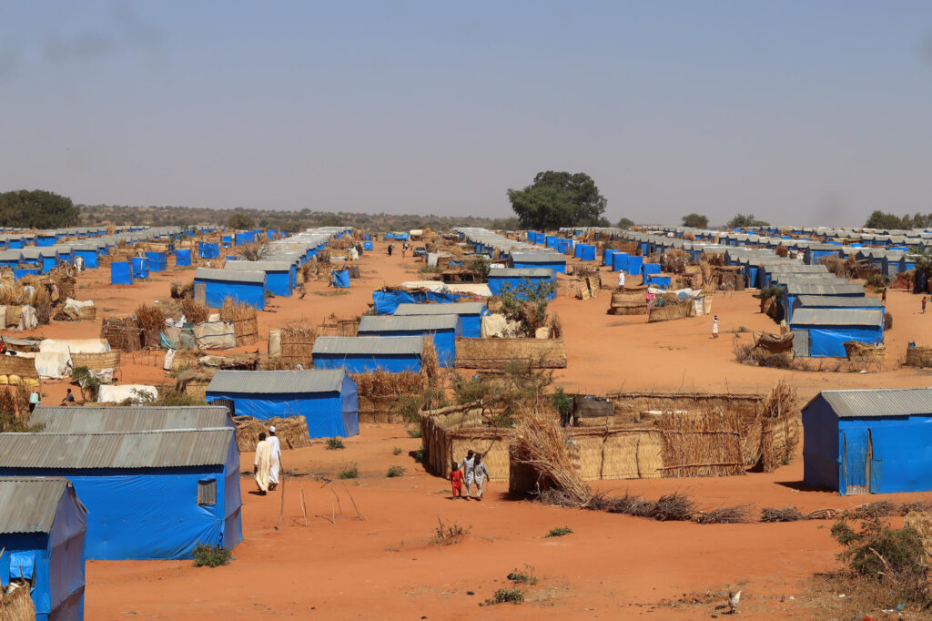
A Sudanese refugee was killed after being struck by lightning during heavy rain at the Gaga refugee camp in eastern Chad on Tuesday, according to camp residents.
Residents said the victim had been collecting water when strong winds and torrential rain swept through the camp.
The refugee was buried on Wednesday.
Tensions later escalated after the body of a Chadian national was found nearby. Refugees accused local residents of cutting off the camp’s water supply.
They also reported shortages of essential goods after many traders failed to open their stalls at the nearby market.
Meanwhile, the Norwegian Refugee Council warned that worsening funding shortages are deepening the humanitarian crisis for Sudanese refugees in eastern Chad.
Spokesperson Trill Eskarsten said aid cuts have left thousands living in makeshift shelters while reducing access to education and child protection services.
She called on governments and donors to increase support, warning that funding decisions have a direct impact on refugees’ ability to rebuild their lives.
