**Deadly lightning strikes again this time Malawi: 5 dead and over 100 injured as lightning strikes on a 12 to 24% increase due to climate change**

Friday, 16 December 2016

http://www.thebigwobble.org/2016/12/deadly-lightning-strikes-again-this.html

[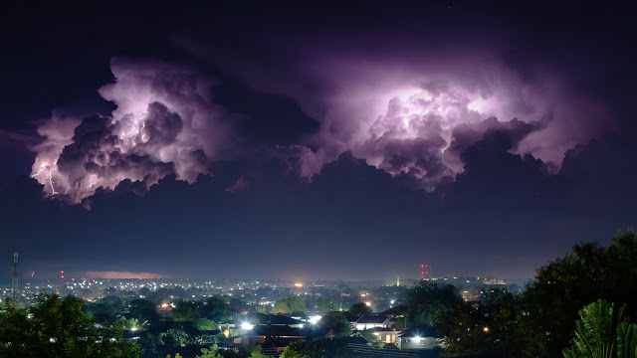](https://2.bp.blogspot.com/-_2seNZrVE5Q/WFPYoIbkAoI/AAAAAAAAgXU/xNjKbs9ij60voKk-19I-yQfGbVTURn3rACLcB/s1600/11275067013_268f8b1fd5_b.jpg)

Photo Flickr lightning over Malawi  
  
Government officials have said rains have killed five people and injured 100 people since they started most of them were struck dead by lightning.

Jeremiah Mphande, spokesperson for the Department of Disaster Management said at least 3000 people have been affected as their houses have been demolished due to heavy rains and hail storm. "Our people are on the ground assisting the affected families," he said.

He however asked people to take precautionary measures by listening to weather information from the Department of Weather and Climate Change. Mphande also asked officials from district councils to submit reports on rains damages to his department as soon as the damages occur.

"Sometimes we take time to get the assessment reports from councils and this delays the issuance of relief items including food," he said.

He said his department cannot distribute relief items without getting assesment reports from affected district councils.

So far Dedza, Chikhwawa, Nsanje and Karonga have been hit hard by the heavy rains which has displaced some people into public schools.