News: Two pupils killed by lightning in Bushenyi – Uganda
https://www.newvision.co.ug/category/news/two-pupils-killed-by-lightning-in-bushenyi-NV_228544_022026
22 February 2026
Bruno Mugizi
The deceased have been identified as Ainembabazi Maria, 7, a Primary One pupil, and Ainomukama Augustine, 10, a Primary Five pupil, both of St Mary's Primary School Kyamuhunga.
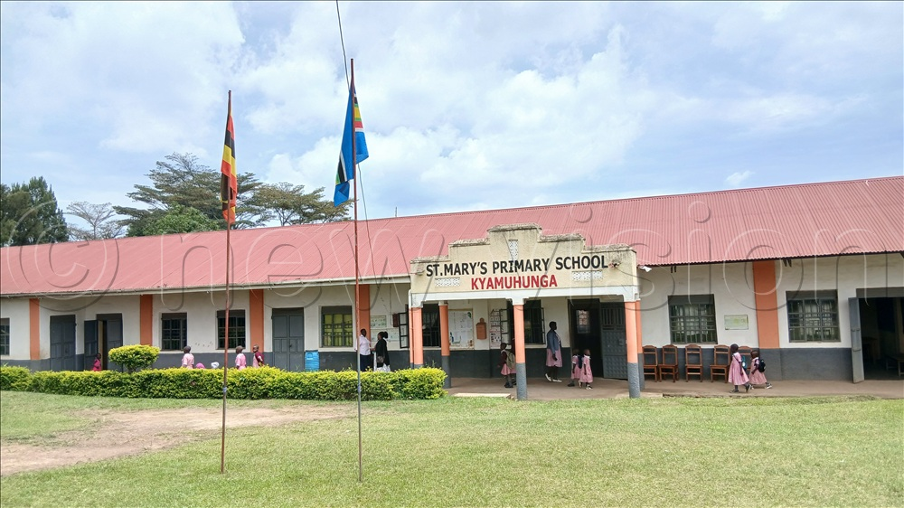
Police in Bushenyi District are investigating the circumstances surrounding the deaths of two pupils who were allegedly struck by lightning.
The deceased have been identified as Ainembabazi Maria, 7, a Primary One pupil, and Ainomukama Augustine, 10, a Primary Five pupil, both of St Mary's Primary School Kyamuhunga.
The two were residents of Gongo Cell, Kyamuhunga Ward, in Bushenyi District.
According to police, the incident occurred on February 20, 2026, at around midday as the children were walking home after lunch near St Mary's Catholic Church Kyamuhunga, close to the school. They reportedly died at the scene.
Territorial police in Bushenyi responded promptly and managed the scene in accordance with standard procedures.
The bodies were conveyed to Kyamuhunga Comboni Hospital for post-mortem examination as inquiries into the exact circumstances continue.
The Greater Bushenyi Regional Police public relations officer, Apollo Tayebwa, said investigations are ongoing.
“We are investigating the circumstances surrounding this unfortunate incident. We urge the public to always observe lightning safety precautions, especially during heavy rains,” Tayebwa said.
“We would like to extend our sympathies to the families of the deceased and pray for the souls of the juveniles to rest in eternal peace,” he added.
Meanwhile, the headteacher, Grace Omwigare, said the incident followed a heavy downpour that lasted close to two hours.
“I was in the school office when I heard a loud thunderclap but did not immediately realise that lightning had struck near the school until students came running to inform me about the incident, which had left two pupils dead,” she said.

