Lightning strike destroys home, kills livestock in Akobo – South Sudan
https://www.radiotamazuj.org/en/news/article/lightning-strike-destroys-home-kills-livestock-in-akobo
4 January, 2026
BY PAUL BAYOCH
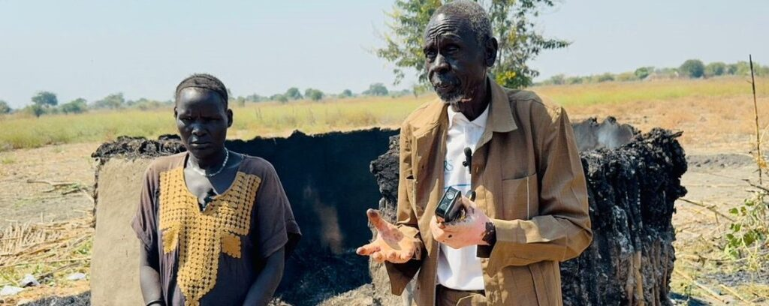
Yat Ngunjock and a family member stand before the debris of their property, which was destroyed by fire
A lightning strike ignited a fire that destroyed a family’s cattle shelter and a children’s sleeping hut in Akobo County early Sunday, killing over a dozen goats and destroying food stores, residents said.
The pre-dawn strike hit the cattle byre of Yat Ngunjock in Wecpuot village. The blaze killed 14 goats and consumed blankets, cooking utensils and bags of sorghum before spreading to a nearby tukul, a traditional round hut, where children were sleeping. The children were rescued unharmed.
Rebecca Nyatiek Majiok, a witness, described the lightning as appearing like “a giant snake spitting fire” that settled on the structure. She said efforts to douse the flames with water failed, with the fire flaring up and burning the buckets used.
Ngunjock, who was in Akobo town at the time, received a distress call from his wife around 3 a.m.
“I have lost most of my belongings,” he said. “I appeal to well-wishers for assistance to recover from this tragedy.”
Some community members expressed surprise at a lightning-caused fire during the dry season. Local lore references a mythical, dragon-like creature known as “Mit,” which some residents speculated could be involved.
The family is appealing for humanitarian support to rebuild. Local authorities have not yet commented.

