**Install lightning arresters in public buildings - Masindi locals – Uganda**

<https://www.monitor.co.ug/uganda/news/national/install-lightning-arresters-in-public-buildings-masindi-locals-5155694>

15 August 2025

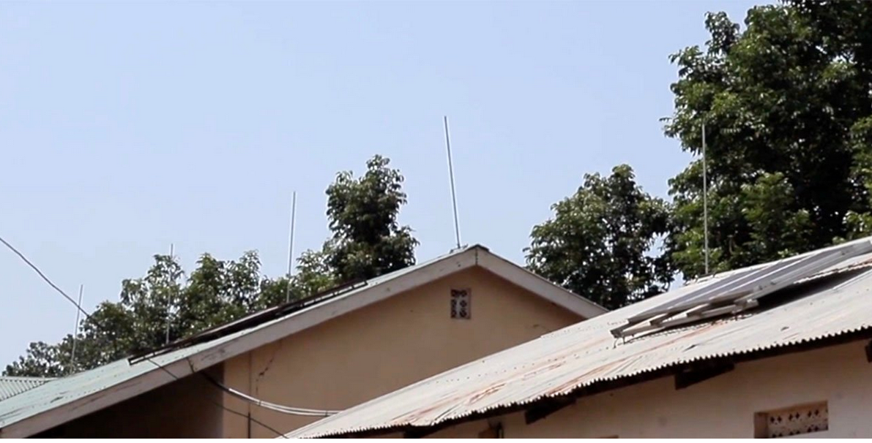

By Ismail Bategeka, Alex Ashaba

Residents of Masindi District are living in fear following the death of five people, who were struck by lightning at Kibibira Market in Kiruli Sub-county on August 8. Residents are now afraid of accessing public buildings and other structures without lightning arresters. They have urged the authorities to ensure that all public facilities have lightning arresters.

During the incident last Friday, lightning struck five people, including market vendors and customers. The tragedy occurred at around 7.45 pm, just as a downpour was easing. Witnesses said the market was still full of shoppers and vendors when the fatal bolt struck a building with no lightning protection.

The shock of the disaster has left many residents demanding urgent action. “This cannot continue. Every rainy season, we are in danger, and we have witnessed that most places don’t have lightning arresters installed. We demand that before a public structure is opened, lightning arresters must be installed before we lose more people,” said Ms Jane Asiimwe, a vendor at Kibibira Market.

A quick survey by this publication on Tuesday found that most public buildings in Masindi Town, including busy markets, schools, and entertainment venues, do not have lightning arresters.

Mr Musa Mugisa, the chairperson of Uganda National Teachers’ Union (UNATU) in Masindi Municipality, said lightning arresters are essential for protecting both lives and property from the dangers of strikes.

He added that for some schools, installation is a costly investment, particularly without the financial support of parents, as government schools rely heavily on limited and strictly regulated capitation grants.

“Some school administrators may not even be aware of how vital lightning arresters are, or of the risks posed by lightning strikes. Schools often prioritise other needs like textbooks, desks, and paying teachers. But these schools cannot function without students, and parents will be hesitant to send children to unsafe classrooms,” he said.

In the business sector, Ms Kasfa Kyogonza, a hotel owner in Masindi Town, said her establishment has no lightning arrester, admitting that for years she did not see it as a priority, choosing instead to focus on other investments.

“Installing lightning arresters can be a significant expense for hotels and similar businesses, and many owners don’t see it as urgent. That is why some in the hospitality industry may not fully understand the importance or the risks,” Ms Kyogonza said.

Masindi Municipal Council mayor Ronald Kyomuhendo said the municipality has begun engaging owners of buildings to install lightning arresters to protect lives.

He also advised the public to avoid seeking shelter in buildings that lack them during the rainy season. “We are calling on both government and building owners to prioritise the installation of lightning arresters in all public spaces, schools, hotels, bars, and other vulnerable structures. You never know when your building will be hit,” Mr Kyomuhendo said.

The Masindi Municipality Central Division chairperson, Mr Issac Bongomin, described the lack of lightning arresters in Masindi’s public places as a pressing safety concern that must be addressed urgently. “During the rainy season, these buildings are not safe. District officials, the Ministry of Education and Sports, and building owners must work together to ensure every public space is equipped with lightning arresters,” he said. “By prioritising safety, we can protect lives and property from future tragedies,” he added.

The Masindi health inspector, Mr Micheal Mudu, said the government should allocate funding to speed up the installation of lightning arresters in all facilities, while urging private property owners to make it a top priority. “Awareness campaigns should be launched to educate the public about the importance of lightning arresters. We can’t wait for another loss of life to act,” he said.

**Lightning Arresters**

A lightning arrester is made of a highly conductive metal, such as copper or aluminium, and is installed at the highest point of a building. When lightning strikes the arrester, the massive electrical current flows directly into it rather than into the building’s structure.

The arrester is connected to thick, low-resistance metal cables that run down the side of the building and are linked to a grounding system — usually a metal rod or a buried copper plate deep in the soil. This grounding system disperses the electrical energy safely into the earth, preventing it from passing through the building’s electrical wiring, plumbing, or occupants.