Urgent Appeal: Protecting Our Children from Deadly Lightning Strikes – South Sudan
https://globalorphanrelief.org/news/2025/08/12/urgent-appeal-lightning-hope-93hh8
12 August 2025
Urgent Appeal: Protecting Our Children from Deadly Lightning Strikes
Please contact our office at 303.840.1123 if this project is something that you would like to fund.
By Rt. Rev. Garang Chan Majok | Executive Director, Christ Mission to the World
Greetings in the precious name of our Lord Jesus Christ.
I am writing to you with a deeply burdened heart over a matter that has brought fear, sorrow, and loss to our community. Though I am currently in Kenya, yesterday I received a disturbing report from the Head Teacher in Beliek crying for help because there was another powerful lightning storm at the Beliek Feeding Centre, which scared all the children and staff. This is now the third time this has happened in the same location. They came up with the plan to set up lightning Arresters in the three feeding centres, to prevent further lightning strikes. We thank God that our staff and children are safe from the lightning strikes of yesterday. The rains are heavy every day, and we need to act quickly.
The report described how the children screamed and ran for cover as the loud crack of lightning struck in the school. Many cried uncontrollably, clinging to each other in fear. Some were so terrified they could hardly be comforted. It breaks my heart to hear of such scenes. Innocent children who come to the feeding centre for nourishment and safety are now associating it with danger and fear.
Tragically, this is not confined to Beliek alone. Similar incidents have been reported in two other feeding centres we operate, as well as in other parts of Aweil during the rainy season. Lives have already been lost; mothers, fathers, and children whose time was cut short in an instant. Each death is a deep wound to the community, leaving behind grief and despair.
Now, when dark clouds gather, the children’s laughter fades. They glance nervously at the sky, their little hands covering their ears, whispering prayers that the storm will pass without another tragedy. This is no way for a child to live in constant fear of what the next lightning strike might bring.
We cannot remain idle in the face of such danger. We urgently need to install three high-quality lightning arresters, one at each affected feeding centre. These devices will safely channel lightning strikes to the ground, protecting our buildings and the precious lives of the children inside. A lightning arrester systems cost $700 each for each location. So we are requesting $3,000, which is the cost of three Lightning arresters and installation. This will ensure strong, reliable protection for all three locations.
We need to act quickly because the rainy season is here, and every storm that passes without protection is another moment of risk. Your timely support could literally save the lives of the children.
The Word of God urges us: “Rescue those being led away to death; hold back those staggering toward slaughter.” Proverbs 24:11 (NIV)
Let us respond with both compassion and action, ensuring that no more lives are lost to this preventable danger.
May the Lord bless you abundantly for all you have done in His Name and your heart for those in need.
With heartfelt thanks and prayers,
Rt Rev. Garang Chan Majok
Executive Director, Christ Mission to the World, Global Orphan Relief Partner
Global Orphan Relief (GO!) in partnership with Christ Mission to the World (CMW) establishes feeding centres at village schools to provide meals to orphan children which has inspired many orphan children to attend school.
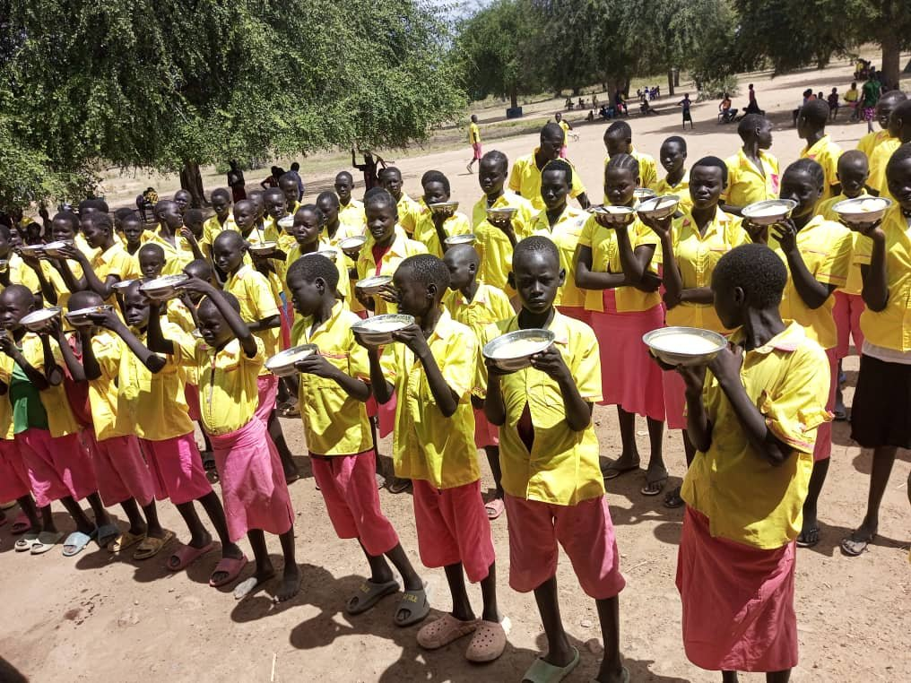
Children at Luethwek, South Sudan, receiving meals.
We have served in South Sudan since 2016 and have provided an estimated 2.5 million meals, impacting more than 3,200 children in South Sudan. The scale of this initiative has grown by over 7 times since our launch in 2016, and this growth is driven by the near-famine conditions, the influx of refugees from Sudan, and other socio-economic challenges in this country.
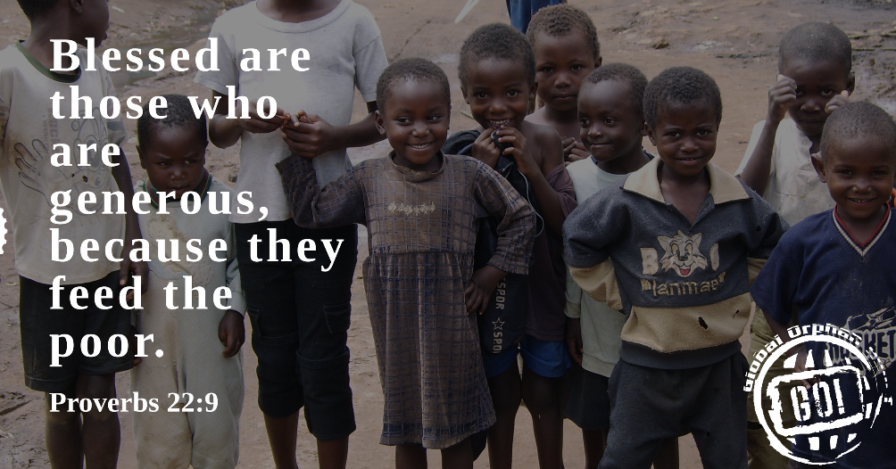
In cooperation with partners, Kids for the Kingdom, Christ Mission to the World, and 200 Orphanages, there has been $183,000 invested in four school sites since October 2020. This investment provides for clean water, kitchens, storerooms, and latrines, all of which allow for cost-effective distribution of food aid in these communities.
Global Orphan Relief (GO) has been serving orphaned children since 2005. We have accomplished this work through local in-country partners that provide oversight and distribution of care.
In 2025, we are working to stabilize our funding for this project and will begin planning for further capital improvements for the locations where we currently provide food aid.
You may send support or other correspondence to Global Orphan Relief, 16352 Prairie Farm Cir, Parker, CO 80134 or you may give also give electronically at Nutrition Initiative or you may give on this website at the upper righthand corner under ‘Donate’ and choosing Nutrition under the Fund designation.
Movement of FAITH | Voice of HOPE | Act of LOVE
Global Orphan Relief is a Christian relief agency serving Orphans in need and a recognized U.S. public charity, tax-exempt under section 501(c)(3). All donations are tax-deductible to the extent of the law.

