Madagascar: an oxen keeper and his animals killed by lightning in Ambohidratrimo – Madagascar
https://freedom.fr/madagascar-un-gardien-de-boeufs-et-ses-animaux-tues-par-la-foudre-a-ambohidratrimo/
10 February 2026
By JRI Editorial Free Dom
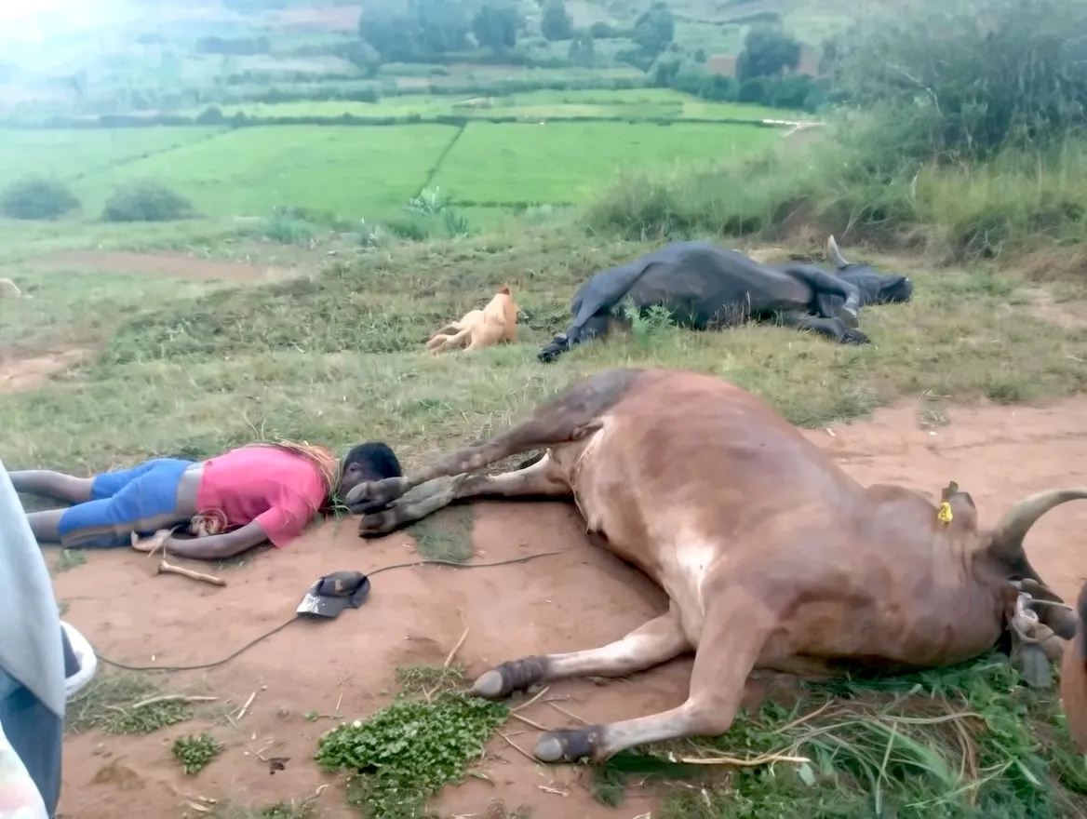
A new weather-related drama occurred in the district of Ambohidratrimo, northwest of Antananarivo. A young ox keeper lost his life after being struck by lightning, along with the animals he was in charge of.
The incident took place in Mahitsy, at the place called Andalana, in the fokontany of Ankadifotsy. According to information gathered by Radio Fivoarana 88.2, the man came back after driving and bringing back the oxen when a sudden lightning impact hit him. The shock was fatal, both for the victim and for the animals that accompanied him.
This tragedy comes in a context of a sharp upsurge in thunderstorms in Madagascar. In recent weeks, several lightning-related accidents have been reported, particularly affecting rural areas, where agricultural and pastoral activities are more prominent in the population.
The local authorities recall the need to increase vigilance during the stormy period, even if these phenomena remain difficult to predict. An investigation has been opened to establish precisely the circumstances of this accident.

