**Nduta (Tanzania): Burundian refugee struck by lightning, community in mourning – Tanzania**<https://www.sosmediasburundi.org/en/2025/04/10/nduta-tanzania-burundian-refugee-struck-by-lightning-community-in-mourning/>

10 April 2025  
  
[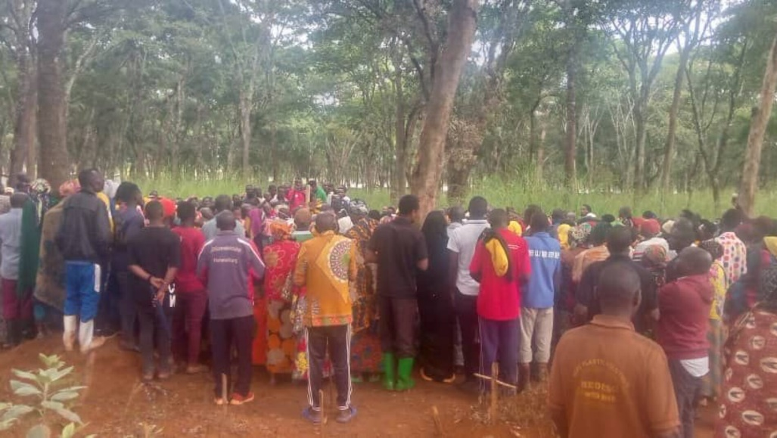](https://www.sosmediasburundi.org/wp-content/uploads/2025/04/6a6061b1-da83-4bc2-9464-8da5aac190de.jpeg)

By SOS Médias Burundi

Nduta, April 9, 2025 — Tragedy struck the Nduta refugee camp in Tanzania. Diane Irakoze, a young Burundian refugee and employee of the humanitarian organization, IRC (International Rescue Committee), lost her life after lightning struck in tragic circumstances.

The tragedy occurred when no heavy rain was falling, although thunderstorms were raging in the area, according to witnesses. She was rushed to the Médecins Sans Frontières (MSF) hospital in the camp, but did not survive her injuries.

Aged in her twenties, Diane Irakoze leaves behind three young children. Her death deeply affected the camp community, particularly in Village 14 of Zone III, where she resided with her family. She was known for her social commitment alongside her husband, who was also involved in community activities.

Her burial took place on the evening of Monday, April 7, in the presence of many refugees who came to pay their last respects. The IRC organization, where she worked, expressed its condolences and pledged to support the bereaved family.

This death has renewed refugees’ concerns about the frequency of lightning-related accidents in the camp. Many are calling on the UNHCR to install lightning rods, particularly in public places, to prevent further loss of life.

The Nduta camp currently hosts more than 58,000 Burundian refugees who have fled the political crisis in Burundi since 2015.  
  
*Burial of Burundian refugee, Diane Irakoze, April 7, 2025 in Nduta (SOS Médias Burundi)*